**1.SQL as a tool for data science**

**Relational databases in data science**

- [Instructor] Relational databases are the workhorses of business data management. They are used to collect, store, and manage transaction data like sales transactions, as well to analyze large volumes of data like those found in data warehouses. It is safe to say the bulk of data used in businesses and other organizations is stored in relational databases. This makes relational databases an important source for data scientists. Now, relational databases are more than just a storehouse for data. They are data management systems that can be used to perform common transformation and analysis operations like linking data across data stores, filtering and reformatting data depending on how it needs to be used, aggregating data to provide kind of a big picture summary, as well as answering specific questions about business operations. Let's consider what goes into a production data science environment. To start, we have **data sources that can include relational and nonrelational databases. Those nonrelational databases, by the way, are often called NoSQL databases. Here, we'll refer to both of these as data stores**. Application and web logs are another source of data for analysis. These are typically less structured than relational data and they may require significant filtering, formatting, and data extraction operations. Also, it's not uncommon to also need small manually curated data sets such as reference data that may be maintained in a spreadsheet. Now, we also have tools for extracting, transforming, and loading data. Data scientists might need data from multiple sources. In these cases, a common practice is to collect data into a single repository prior to analysis. For example, an analyst might extract data from a transaction processing database, an application log, and a personally managed spreadsheet, and then store that all in a relational database. Now, if it's a really large amount of data, the data scientists may use a big data platform such as Hadoop or Spark. Transformations are operations performed on data to make the data more suitable for analysis. Now, we often need to reformat dates, replace missing values with zeroes, and strip out trailing blanks from strings. Some analysis like building machine learning models can require additional transformations such as changing the scale of numeric values or using even more involved calculations to estimate missing values. Loading an ETL process occurs when data is moved into a data store for analysis. Now, this sounds simple, but large data sets can require specialized techniques like parallel data loads to ensure that the data is loaded in a reasonable period of time. Analysis and modeling tools are used by data scientists for a range of activities like identifying useful information, building predictive models, detecting anomalies, and to make any recommendations. These tools read data from data stores and may write results back to databases as well. The final result, of course, is insight into business problems and relational databases play key roles throughout the data science process, that ultimately lead to those insights.

### SQL data manipulation features

- [Instructor] SQL has two types of commands. Data manipulation commands and data definition commands. We'll look at data manipulation commands in this video and discuss data definition commands in the next. Before discussing specific commands, let's understand why data scientist need to know these commands to do their work. A majority of data science work is about collecting, cleaning, and restructuring data. Only after that preparation can we move ahead with analysis work. A common assumption is that about 70% to 80% of time on a data science project is spent on data manipulation, much of that time is spent working with SQL. INSERT is a SQL command for putting data into a table. INSERT statements include the name of the table, the name of the columns with values being inserted, and a list of values to insert. A simple INSERT command puts one row into a table. This set of three INSERT commands adds three rows to the table. The UPDATE command is used to change data that is already in a table. The UPDATE command includes the name of the table to update, the columns that will be updated and the new values that will be assigned, and optionally a WHERE clause that filters which rows will be updated. For example, this command changes the country name from USA to United States. If a WHERE clause is not specified, then all rows in a table are updated. The DELETE command is used to remove rows from a table. The command includes a table name, and an optional WHERE clause to determine which rows should be deleted from the table. For example, this DELETE command removes those rows from the table that have Canada as a country value. If no WHERE clause is specified, all rows in the table are deleted. The SELECT command is used to retrieve data from a relational database. It has many options and features that make it a valuable tool for data scientist who are exploring, collecting, and analyzing data. In this lesson, we will only briefly discuss the SELECT command but later videos will go into more options. The SELECT command includes one or more table names, a list columns to retrieve, optionally one or more joins of tables, a WHERE clause, aggregate functions, and sorting and grouping commands. A SELECT command includes at least one table name indicating which table to retrieve columns from, a list of columns to retrieve from a table, and this may be the special symbol star which means return all columns. This command shows how to retrieve all columns from all rows in the country regions table. Optionally, a WHERE clause can be used to filter the rows returned. As in this example, which returns only rows with the specified row IDs. In the next video, we will quickly review how to create tables, views, and indexes.

### SQL data definition features

- [Instructor] SQL has two types of commands: data manipulation commands, and data definition commands. We're going to discuss data definition commands in this video. Data definition commands are used to define structures for organizing data in a relational database. Imagine you need to manage thousands of paper reports for your job. Now, you could just leave this in a pile and search through the pile every time you need to find a particular report. However, it's much easier to find a paper report when they're organized in boxes by type of report and then organized within a box by date. The same idea applies to organizing data in a relational database. We structure data using tables, which are collections of related data records, indexes, which are sets of data about the location of records, views, which are used when we repeatedly want to access the same set of data from one or more tables, and then finally schemas, which are collections of tables, indexes, views, and other data structures. Tables are used to organize related sets of data, like information about employees, products, and events. We use the CREATE TABLE command to define a table. The CREATE TABLE command includes the name of a table. In this case, the name is staff. Next is a list of column names, such as id, followed by a data type, such as INTEGER. Tables typically have multiple columns. Each column is used to store one piece of data. Each column has a data type. Some of the most commonly used data types are integers, varchars, which are for varying length character strings, and dates. There are many more types for representing more specialized kinds of data, from monetary units to JSON structures. The CREATE TABLE command has a clause called PRIMARY KEY. This indicates which column or set of columns uniquely identifies each row. When a primary key is defined on a table, whenever a row is inserted into the table, it must have values in the primary key column or columns. Also, that key can't already exist in the table. It has to be unique. Often, we want to look up one piece of information in a table. This is like finding a single book in a library. Before libraries had databases, they used card catalogs. These were file cabinets filled with cards with information on where to find books. So you could look up a book by name, and that corresponding card would indicate where in the library you could find the book. Using the catalog is a lot faster than walking through the library, checking every book on the shelves. Indexes in relational databases serve the same purpose. The CREATE INDEX command lets us build an index to quickly look up rows and tables. The CREATE INDEX command takes the name of the index. It's a common practice to use a prefix like idx to indicate that this is an index. The ON clause indicates which table will have the index. The keyword ON is followed by the name of the index table. The USING clause indicates the columns that will be used in the index. In this example, the last name of the staff member is used in the index. This command will allow the query engine of the database to quickly find the row of data by last name. Now, views are structures that help us focus on the most important data for a particular use. For example, someone in human resources might be interested in knowing an employee's start date and their department name while someone else in finance might be more interested in their salary. Views help make it easy to query data without including unneeded columns in our results. Views also help retrieve data from multiple tables without having to repeatedly specify joins. The CREATE VIEW command creates a view. The command includes a name for the view. This view name is staff_div, indicating that it includes columns from the staff and company division tables. The next section of the CREATE VIEW command is a SELECT statement, which defines the columns to include in a view. The columns in this SELECT statement use a prefix, such as s or cd. These are called aliases. They're a short-hand way of indicating which table is a source for each column. The FROM clause indicates the tables used in the view. In this case, it also includes an alias. When multiple tables are used, there's often a JOIN between tables. The JOIN clause indicates how to link rows between tables. The LEFT JOIN is used when all rows from the left side of the equal statement should be included, even if a corresponding column is not found on the right side table. In this example, the s or staff table is on the left, and the cd or company division table is on the right. Schemas are like floor plans. They organize groups of related structures such as database, tables, and views. The CREATE SCHEMA command tells the database management system to create an organizational space, and in that space, we will keep related tables, indexes, views, and other structures. The schema command takes a name of the schema. Now, depending on the database management system that you are using, there may be additional clauses in the CREATE SCHEMA command. Data definition commands create data structures for organizing data. The top-level grouping is a schemas. Schemas can have multiple tables and each table can have optional indexes. Views can also be created to streamline querying, allowing developers and analysts to focus on the most important columns and easily retrieve data from multiple tables.

### ANSI standard SQL and variants

- [Instructor] SQL is a language that has changed over time. Databases offer different versions of SQL, so when we talk about SQL in general, we usually refer to the ANSI standards SQL. The American National Standards Institute, known as ANSI, defined a standard version of SQL in the mid-1980s. Since then, the standard has been updated seven times to add features, many of which are useful to data scientists. With changes over time in the standard and database management systems offering different versions of SQL, what does this mean for data scientists? It means the SQL implementation that you use may be different from the current ANSI standard and it may be different from the SQL used in this course. The foundational SQL commands like insert, delete, and most create commands will be the same across implementations, but you should check your database documentation, especially for missing data types and functions. Some databases like MySQL do not support windowing functions, which are really quite useful for some types of data science analysis. In addition, other databases like PostgreSQL offer geographic data types that are not generally available.

2. Basic Statistics with Postgre SQL

### Installing PostgreSQL

- [Instructor] It's time to install our database. We'll be using PostgreSQL, also called Postgres for our work. Let's start at the Postgres download page at www.postgresql.og/download. There are a number of options for different operating systems. I'm working on a Mac, so I'll select the link for that option. Now there are several ways to install Postgres on a Mac and I'm going to use the Enterprise DB interactive installer. It's easy to use and it's available for Mac, Windows and Linux operating systems. So I'll click on the link for that. I'll select the most recent version of Postgres and the Mac OS X operating system. If you're using Windows, you can select the appropriate Windows version for your platform. And I'll select download now. Now that the Postgres package is downloaded, I'll open it and start the installation. Now a dialogue message will appear on a Mac operating system, but you may not see this in Windows. I'm simply going to agree to open, and I'll provide my operating system password. The installation may be slightly different in Windows, but the process is basically the same. So, the wizard has started. I'll select next. I'm going to choose all the defaults and I'll give a password for the database. We'll want to remember that. We'll need that when we access the database. Now while Postgres is installing, I want to mention that one of the advantages of using the Enterprise DB installer, is that it automatically installs pgAdmin, a GUI admin tool that we'll be using. We don't need any additional packages, so I'll **uncheck the stack builder** option, and select finish. Now, I'll start pgAdmin. Now you may see a notice that there's a newer version of pgAdmin available. We're just going to ignore that. This version works just fine for what we're doing. In the **left pane**, you'll see a hierarchical navigation control that includes a **Postgres database. Let's open that** and I'll specify the password I provided during the installation. Now, there is a Postgres database that is the default database. But I want to create a different one for our project, so I'll going to control click on the Mac, or **right click in Windows**, and I'm going to **select create database**. I'm going to **create a database called data_sci**, short for data science. I'll save that. Now, let's open data_sci and **navigate down through schemas**, through the public schema, and let's take a look at the things that are available. We have, for example**, a list of tables**. If we click on that, we'll notice that there are no tables listed. **We'll create tables and insert data next**.

### CREATE TABLE and INSERT DATA:02_02 file

- [Instructor] Now I have **pgAdmin started,** and I'm going to click on the Tools menu, and select Query Tool. This will open a query window. Notice, in the blue bar in the query window, it says data_sci on postgres. That means we're working with the data_sci database, which is what we want. So now, let's open a script file. And if you have access to the exercise files, you'll want to open the mock_staff.sql file, which I have in my user directory, and I will open that, mock_staff, and I will select that. And what you'll notice here, mock_'s staff table **includes a series of create table statements and insert statements, and this will create the schema** and the data that we'll need for our exercises. So I'm going to go up to the Execute button, and I will execute this statement. And that has finished executing. Now let's Control click on the Tables item in the hierarchical navigation, or right-click if you're using Windows. And let's select Refresh. And now let's open the Tables again. What you'll notice is we have three tables, company_divisions, company_regions, and staff. So let's take a look at their contents. I'll open another query window. pgAdmin lets you have multiple query windows open at once. This helps when you're working with multiple queries. So first, we'll query company_divisions. SELECT * FROM company_divisions, and we'll execute that. And you'll notice we receive 21 rows back, and the two columns in this table are a list of departments and then the company divisions to which those departments belong. So, for example, Baby, Beauty, and Clothing are all in Domestic, while Computers and Electronics are in the Electronic Equipment division. Now, let's look at company_regions. And we'll execute that, and we'll notice this is slightly different. We have an integer ID for our key, and we have a series of geographic regions, each grouped into one of two countries. The staff table has information about employees at this fictional company. We'll select * from staff and execute. We'll notice we have a thousand rows returned. The staff table includes columns for the last name, email address, gender, department, start date, salary, job title, and region id. We'll be using these tables to demonstrate some useful ways to use SQL for data science analysis.

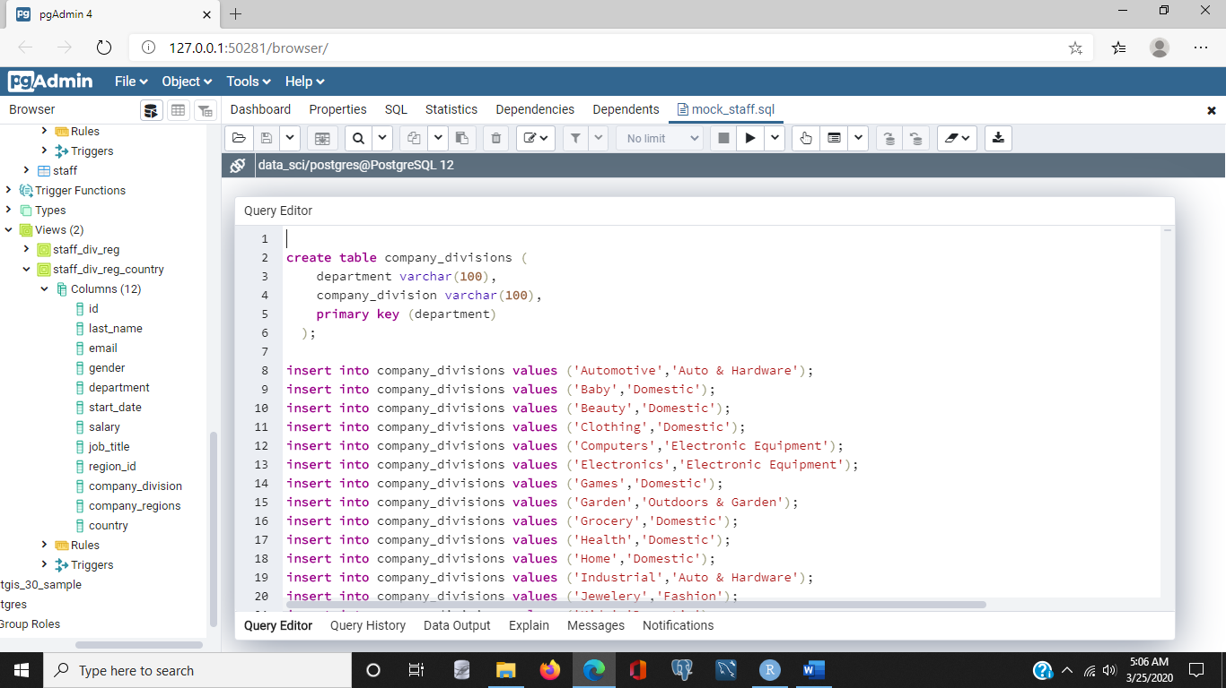

### The COUNT, MIN, and MAX functions-02_03 csv file

- [Instructor] Starting with PGM in open select the data sci database and within that the public schema. Next click on the **tools menu** at the top of the screen and select **Query Tool**. This will open a sequel window. We'll do most of our work in query windows like this. The top window has an area where we enter sequel commands. The results of our queries will appear in the bottom panel. Let's type a simple select command in the query window. Select, star, from, staff. I'm just going to move the results pain down slightly. Click on the execute button which has the lightening bolt icon. This will execute the query. Notice the query result rows appear in the lower pane. You can scroll through to see the rows. One thing that I like to do when I'm checking a table is to just return the first several rows instead of retrieving all of them. This is especially useful when working with large tables. So I'll **add a limit clause** and restrict it to the first 10 rows. I'll then click the query execution command and you'll notice that we have rows down here. We have nine showing and 10 actually. So the results are limited to the first 10 rows when we use the limit clause. Okay, now let's work with some basic aggregate functions. Let's start by counting employees across the company and then across different groups. So the first thing I'll do is remove this limit clause, since I want to work with the whole set of employees. The first I want to do is simply count the number of people in the company. I'll use the count function and I'll count everyone in the staff table. I'll execute that command and you'll notice the count returns 1000 rows. And that is correct. There are 1000 employees in the staff table. Now, let's count by gender. So the first thing I want to do, is I want to count the staff, but I want to group by gender. And this will count how many employees are in each gender group. So execute the statement. And notice I have two numbers coming back now. 496 and 504. Problem is, I don't know which is female and which is male. **The problem is I did not include gender in the list of columns to return in the select statement**. So I'll add gender now, and I'll say return the gender and the count for each gender in the table. And I'll execute. And now you'll see I have the indicators of which is male and which is female and their associated counts. Let's do a little different grouping next. Instead of grouping by gender, let's group by department. And I'll group by department here. So I'm grouping by department. I'm including the department name along with the count in the rows that are returned. I'll select the execute statement. And you'll notice here I've had 22 rows returned. That's because there are 22 distinct departments in the database. As you can see I have the count of the number of employees in each department. So now that we've looked at counting let's look at a couple other aggregate functions that are commonly used. Those are the max and the min functions. Let's say I want to know what is the salary of the highest paid employee. Well the first thing I want to do is I want to select the salary, but I also want to select the maximum salary. I don't want all of them. So I'll use the max function. And I'll say select the max from staff. I don't need to group by anything because I want to go across the entire set of employees. And when I click that I'll notice that the highest salary is approximately $150000. Roughly. Now I may also want to know what's the minimum salary that any employee is paid. I can use the min function for that. So again I'll execute the statement with that command, and I'll notice the lowest salary is about $40000. Now sometimes I want to see both the max and the min salary at the same time. And that's no problem. I can include both the max and the min in the same select statement. And I'll execute. And you'll notice I have the maximum and the minimum both returned. Now, just as we can count rows in groups we can also apply the max and min functions to groups of subsets of rows. So let's show the minimum and maximum salary in each department. Well I want to group by department, but I also want to remember to include the department name in the results. So now what I'm doing is I'm selecting for each department, find the maximum and minimum salaries and then present them all back to me. So I'll select the execute statement and now you'll notice here once again we have the list of the 22 different departments, but we also have the minimum salary paid to anyone in that department as well as the maximum paid to anyone in that department. Now, just as we had used gender before in our counts, we can also use it here. So we can again group by gender. Find the min and max salary. And we can group by gender. And we click the execute button. And now here we have the min and max salaries for male and female, and we have that across all of the staff.

/* Start with a simple select statement */

select * from staff;

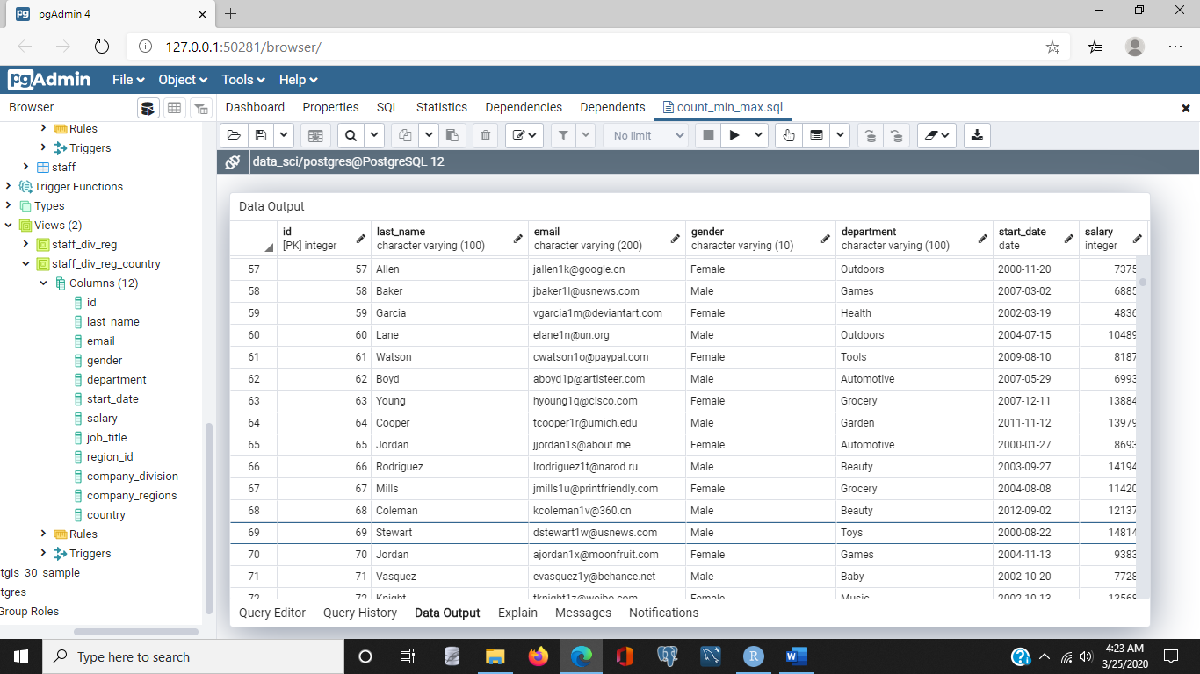

/* Show the number of rows in the table staff */

select count(*) from staff;

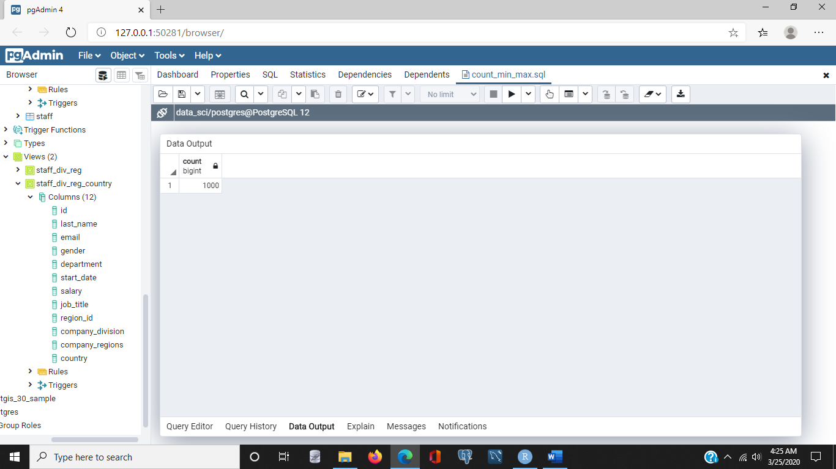

/* Show the number of staff members by gender */

select

count(*)

from

staff

group by

gender;

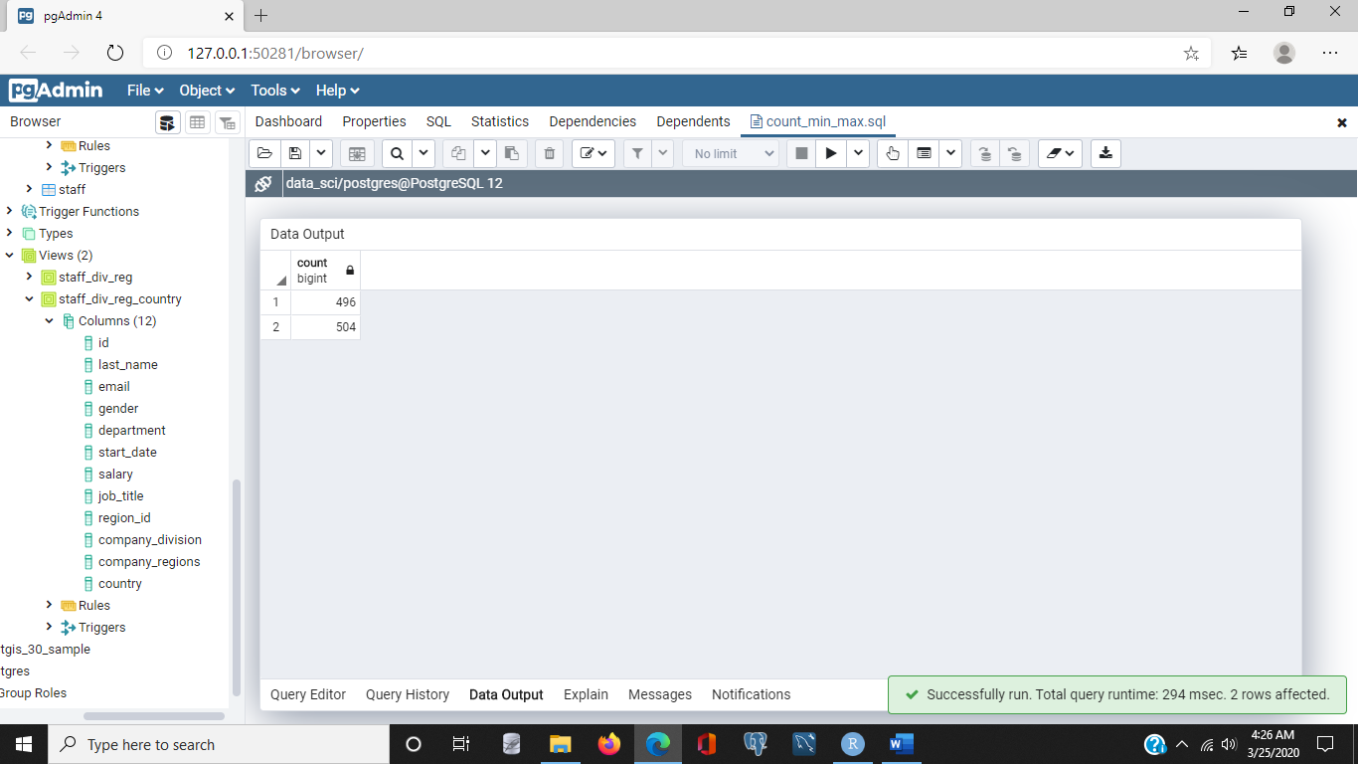

/* Now, show the number of staff member by gender and include the name of the gender */

select

gender, count(*)

from

staff

group by

gender;

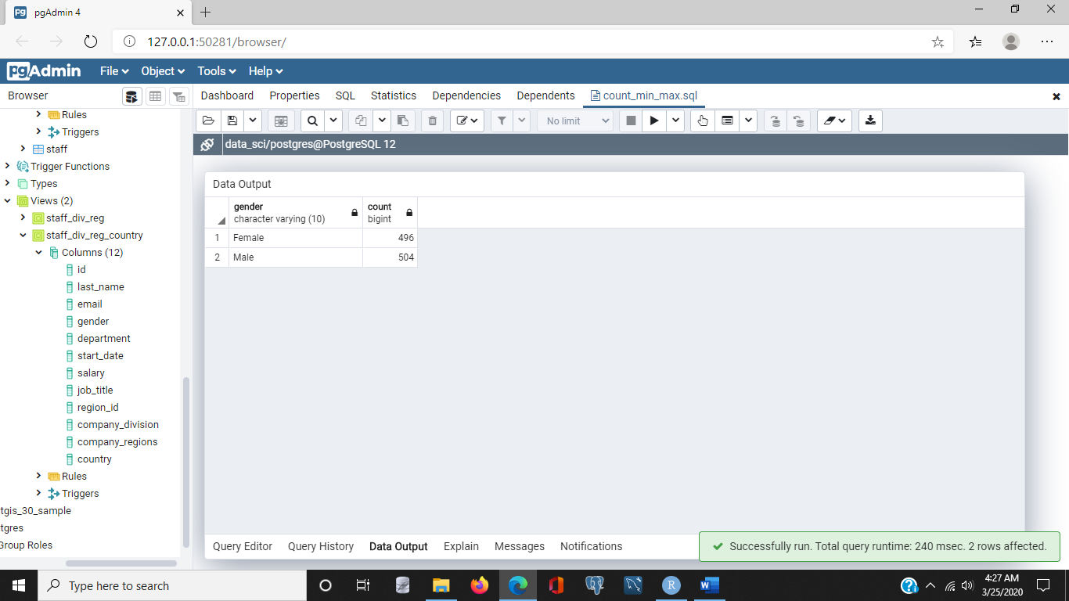

/* Show the number of staff members in each department */

select

department, count(*)

from

staff

group by

department;

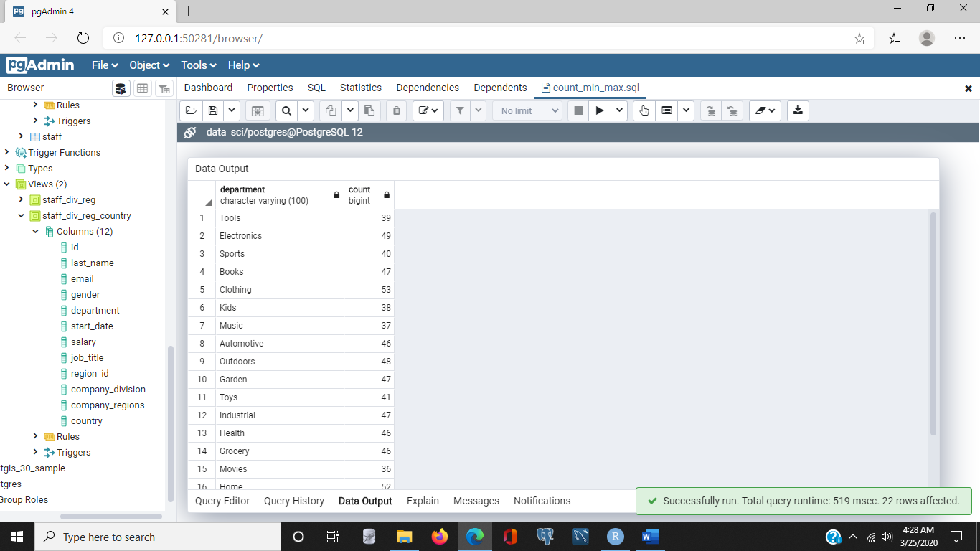

/* Show the maximum salary of all staff member */

select

max(salary)

from

staff;

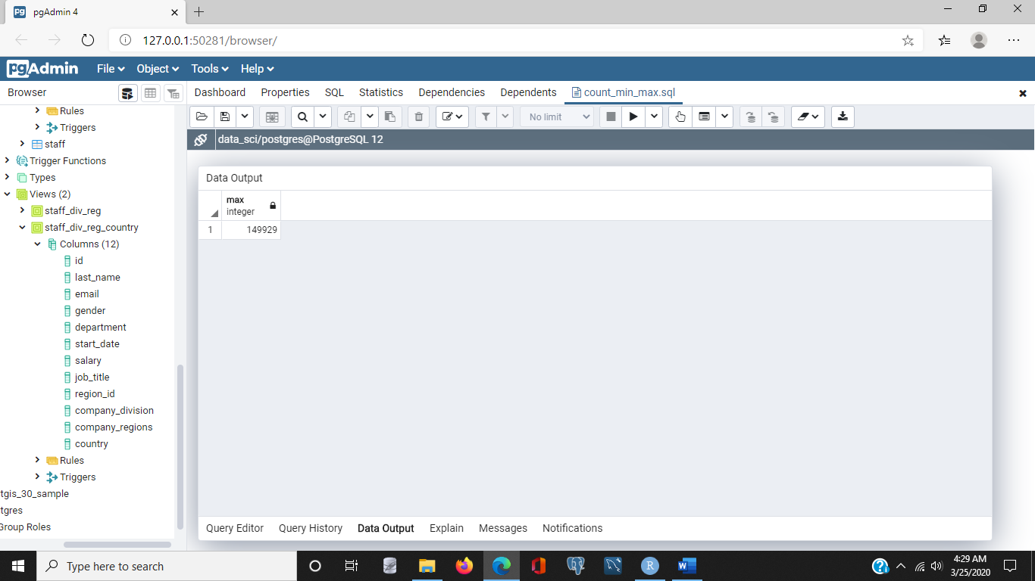

select

min(salary)

from

staff;

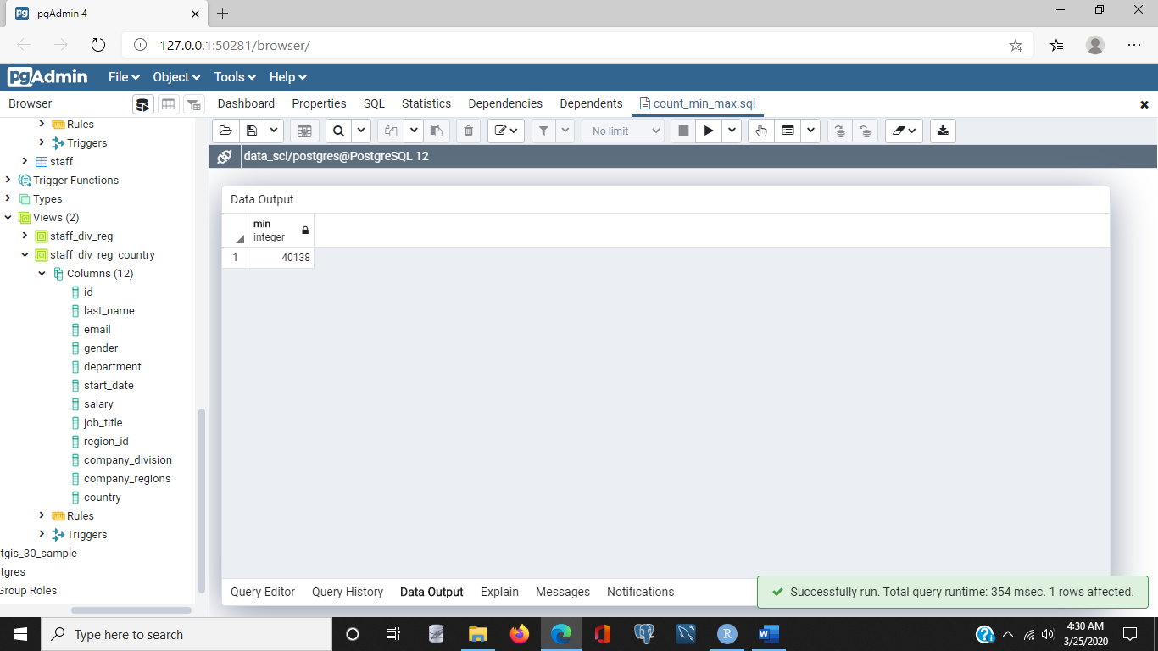

/* Show the minimum salary of all staff member */

select

min(salary), max(salary),last_name,gender,department

from

staff

group by last_name,gender,department;

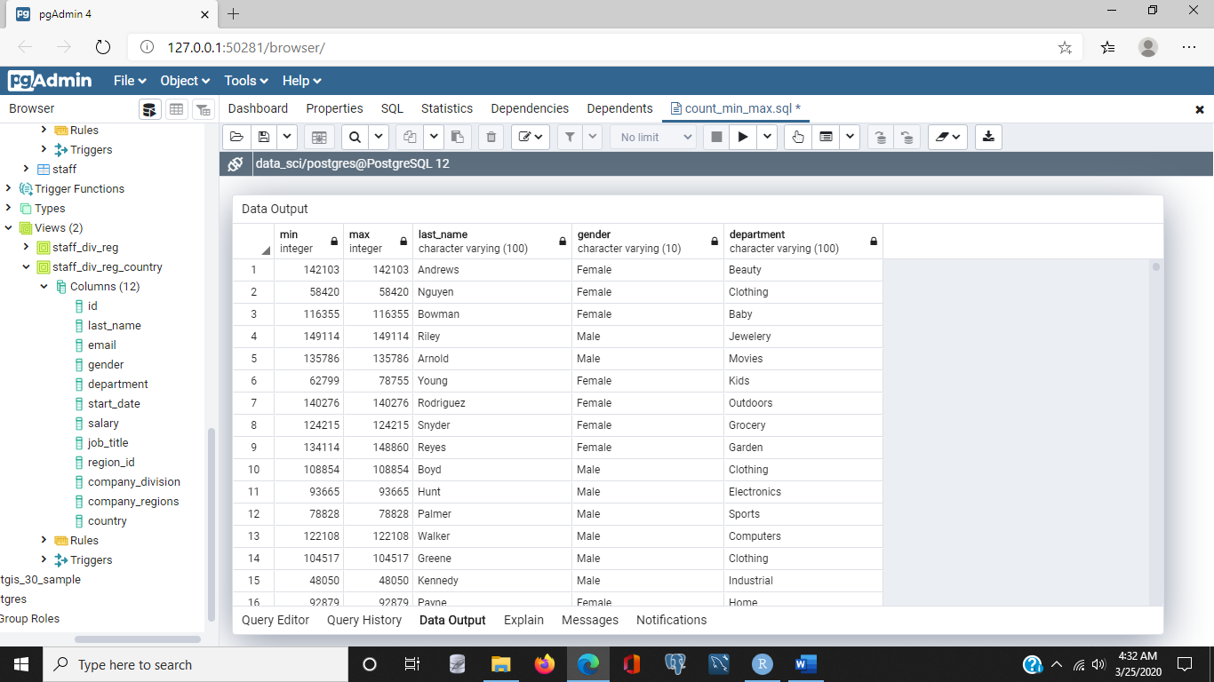

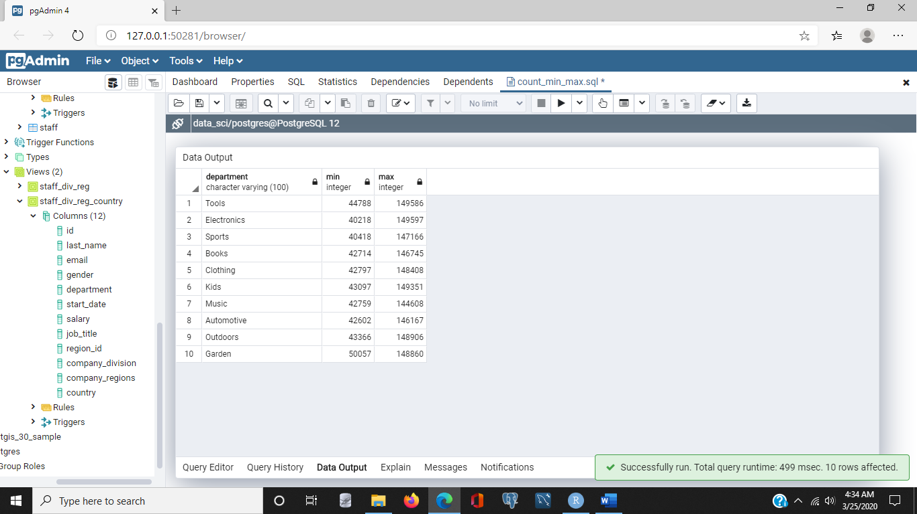/* Show the minimum and maximum salary in each department */

select

department, min(salary), max(salary)

from

staff

group by

department

limit 10;

/* Show the minimum and maximum salary by gender */

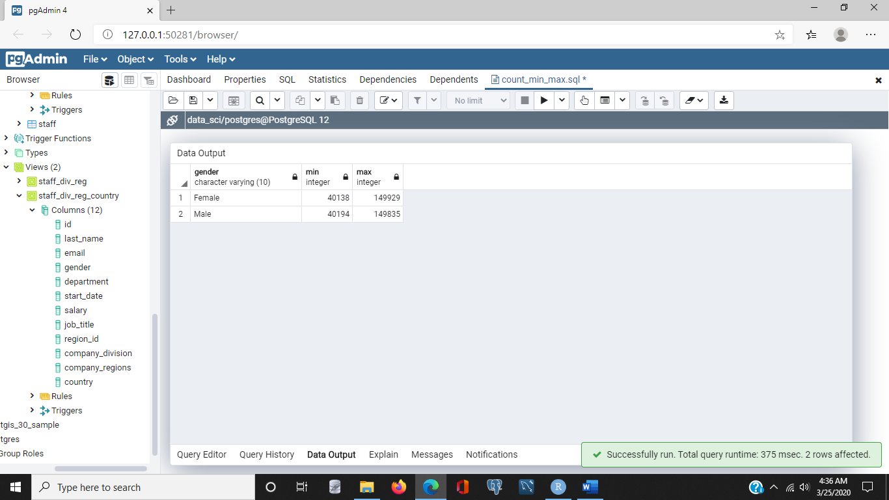select

gender, min(salary), max(salary)

from

staff

group by

gender;

/* get anything */

select job_title, start_date, max(salary), gender

from staff

group by job_title, start_date, gender

order by max(salary) desc

limit 25;

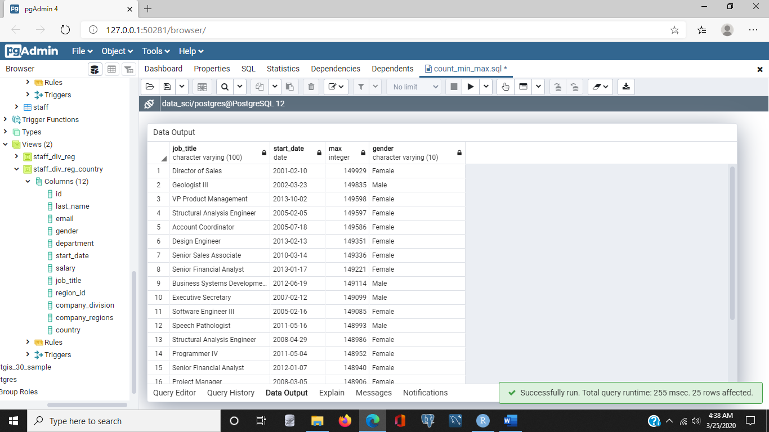

### Statistical functions:02_04 file

- [Narrator] Data scientists often use statistics to better understand data sets. SQL includes functions for describing data sets, so let's see how to use some of the most commonly-used statistic functions, to better understand our data. I'm going to start by selecting from the staff column, I will select star, from staff, and I'll limit this to 10, cause I'm just trying to get a feel for the data. And we'll notice that this table includes information about employees, which includes some string characters and some dates, and some integer values to work with. Now, one of the things I might like to know is, how much does the company pay in salary to all of its staff, across a given year? Well, the way to do that is to first of all, we'll remove the limit clause, cause we want to look at everyone, and we want to use the sum function, which is one of those statistic functions, and it's applied to a column, like salary, and I'll execute the query, and notice that the result is approximately $97.3 million is paid per year, across all of the staff. Now next, I might like to understand how much does each department pay in salary? Well, to do that, I'd want to use the group by clause again. So I will group by department, and I'll be sure to include the department name in the results set. I'll execute that query, and I'll notice that I have 22 rows returned, one for each department, and also, a value of the total amount spent in salary each year for that department, okay, that's really useful information. Different departments may have different number of employees so it's also helpful to understand what's the average salary paid per employee in department. To find that, I can use the AVG or average function, and ask for the average salary, and since I'm grouping by department, the average function will calculate the average salary per department, and I'll simply execute the statement, and now we'll notice that I have a third column added. And I'm just going to spread it out here, to make it easier to read. And this is the average salary per department. There are a couple of other statistics that are sometimes used by statisticians and others who are familiar with statistics. These are called the variance, and standard deviation. We won't go into details about what these mean, but I'll roughly describe them as both good ways of measuring how spread out data is around an average. So, let's look first at the variance, and how to calculate that. SQL has a function called **var pop,** short for **variance of population, and that's applied to a numeric column,** like salary. And when we execute this statement, we'll get a fourth column added to our results set, and this is known as the variance. I won't go into details about it, but it's a good way of measuring how spread out the data is. A more commonly used statistic for understanding the distribution of data is something called the standard deviation. In SQL, that function is **stddev**, underscore pop, which is short for standard deviation of population. And we want to know the standard deviation over the salary, so we'll use that function, and execute, and again, another column is added to our result set, and as we can see, this number indicates the standard deviation over the salary, by department. Now you'll notice that when we use functions like average, and standard deviation, we're getting a lot of decimal places after the decimal point. Since we're talking about salaries, we're talking about monetary values, it's probably helpful to round these to two decimal points. To do that, we simply use the **round function**, and apply it to the average, the variance, and the standard deviation. So I'll do that right now, I'll add round, and one of the things I want to do is tell the round function to round the average salary, and keep just two decimal points, and I'll do the same thing with variance, I'll ask to round it and keep just two decimal points, and finally I'll do the same for standard deviation. And when I execute, you'll notice that each column that has the round function applied to it, has only two decimal places, this makes the results a little easier to read. Now I will say, if you're not familiar with statistics, and terms like variance and standard deviations are not things you've come across before, that's nothing to worry about, it's just important to know that if you do need them in the future, the functions are available to you in SQL.

/* Show the first 10 rows of the staff table */

select * from staff limit 10;

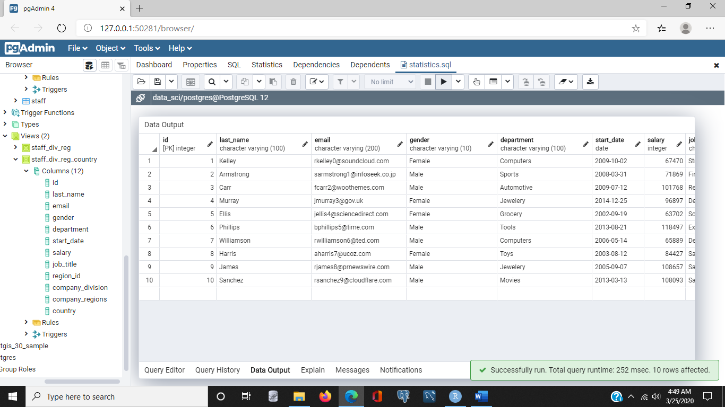

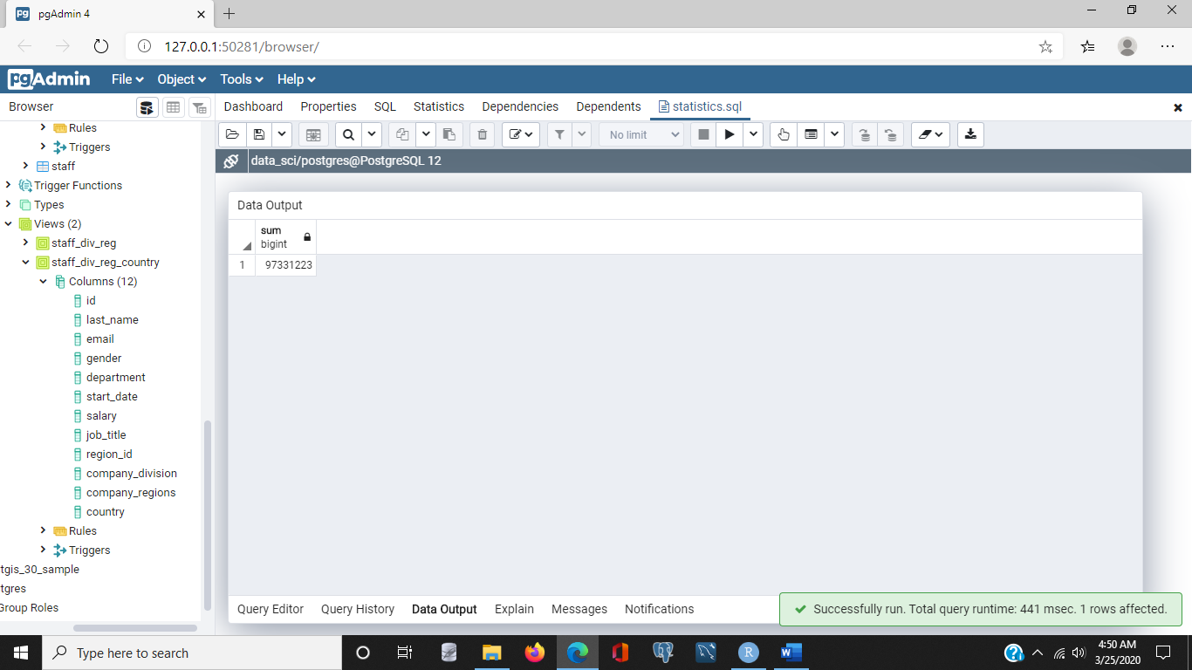/* Sum the total amount of salary paid to staff */

select sum(salary)

from staff;

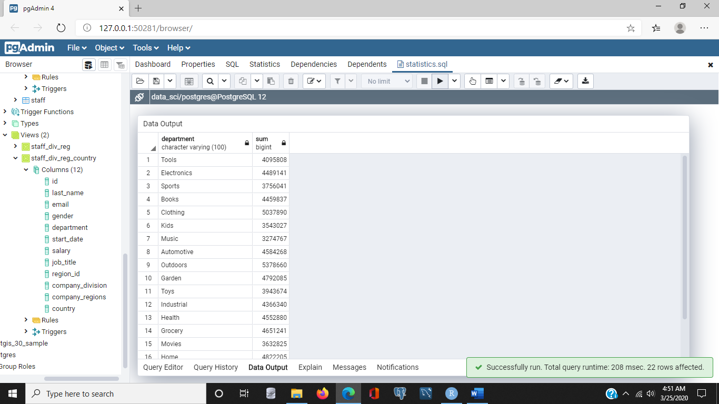/* Sum the total amount of salary paid to staff by department */

select

department, sum(salary)

from

staff

group by

department;

/* Sum the total, and average (or mean) amount of salary paid to staff by department */

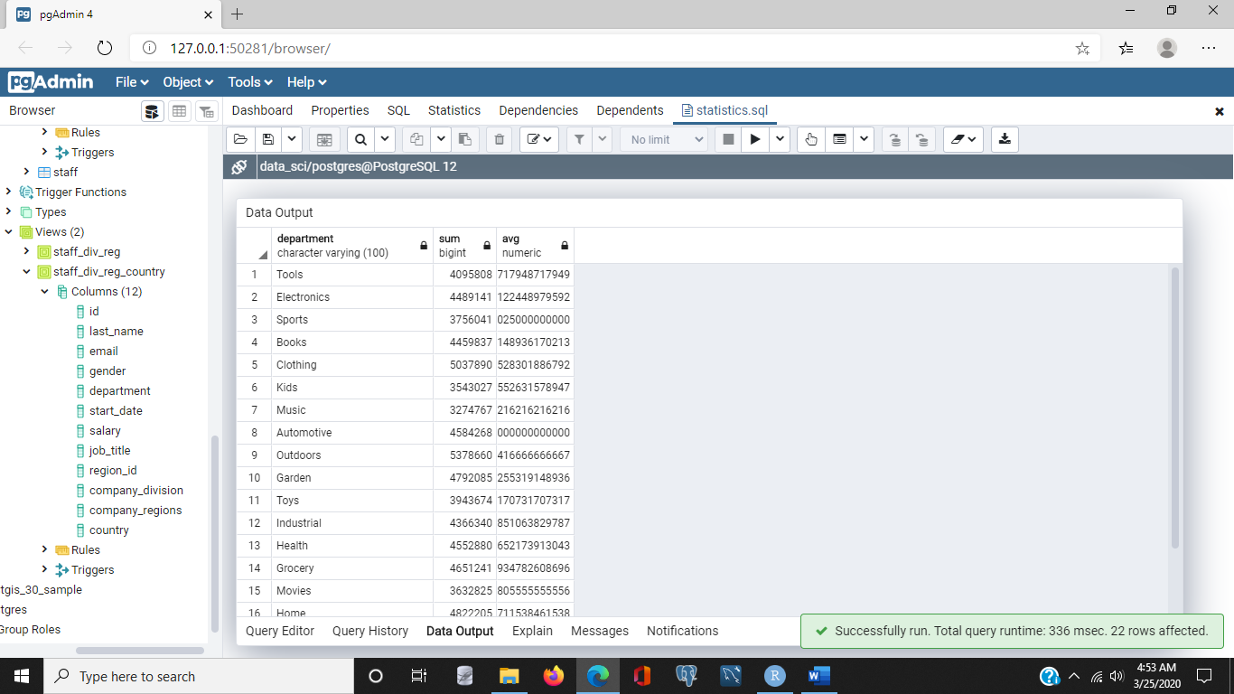select

department, sum(salary), avg(salary)

from

staff

group by

department;

/* Sum the total, average (or mean) and variance of salary paid to staff by department */

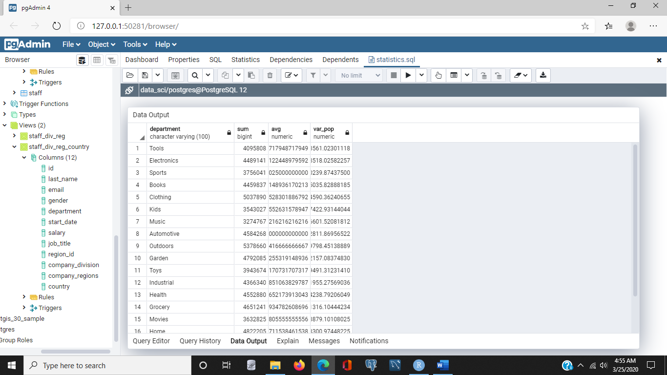select

department, sum(salary), avg(salary), var_pop(salary)

from

staff

group by

department;

/* Sum the total, average (or mean), variance and standard deviation of salary paid to staff by department */

select

department, sum(salary), avg(salary), var_pop(salary), stddev_pop(salary)

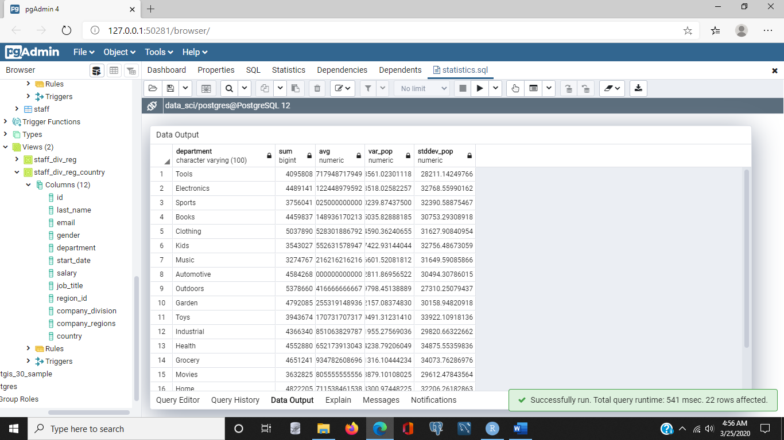from

staff

group by

department;

/* Use round function to round to 2 decimal places */

select

department, sum(salary), round(avg(salary),2), round(var_pop(salary),2), round(stddev_pop(salary),2)

from

staff

group by

department;

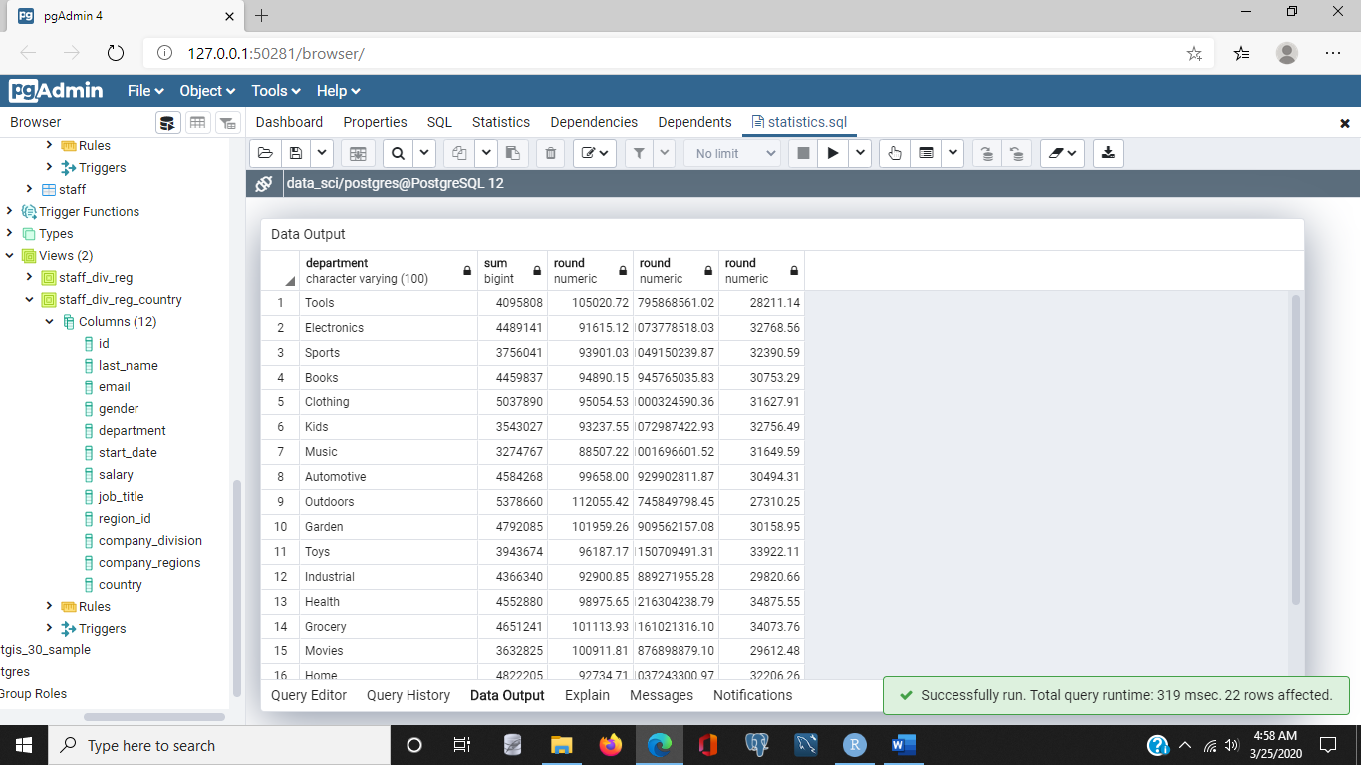

### Filtering and grouping data: 02_05 file

- [Instructor] Two common tasks in data science work are **filtering data** so we can work with just the data we're interested in, and the other is grouping data so we can calculate values for an entire group such as a product category or a department. Let's start with filtering data using numeric values. We'll use the staff table for this example. Let's assume **we want to list everything with a salary greater than $100,000.** So I'll use the select command, and for this example, we'll include the last name, department, and of course, salary. And we will select this from the staff table. Now, we only want to include a certain subset of the employees, so we use a WHERE clause. We're going to say WHERE salary is greater than 100,000, and if we execute that statement, we'll get a list of employees who work in various departments, but all of whom earn salaries over $100,000. **Filtering based on character strings** works in similar ways. Now, let's generate a list of employees who work in the tools department, and we'll keep the columns the same. So I'll just change the WHERE clause to say WHERE department = tools, and I'll execute that statement. And now all of the employees listed are in the tools department, and if we were to browse a little bit, we'd notice that yes, in fact, they are all in the tools department. Now let's combine the two filters. It's pretty **common to have more than one condition we want to filter on**. In fact, sometimes WHERE clauses can be the longest part of a select statement, because there are so many conditions that need to be satisfied. To filter for rows that **satisfy both conditions**, we use the AND keyword. So I'll include that in my WHERE clause, and I'll say WHERE department = tools AND salary > 100,000. And we'll execute this statement, and we'll notice that sure enough, everyone listed here is in the tools department and has a salary greater than $100,000. Now, if we want **at least one** of the conditions to be met but maybe not both, then we can use the OR keyword. And I'll change the AND to OR, execute that statement, an you'll notice, now we have some people who work in departments other than tools, but all of the people who aren't in the tools department have salaries over $100,000. And if we browse a little bit, we'll notice that some of the people in the tools department are listed, but they have salaries less than $100,000. For example, in this case, Watson is in the tools department and earns a salary of $81,870. Now, in SQL, the LIKE **operator is used to match patterns**. There are many options for working with the LIKE operator. For example, if we wanted to look at all of the departments that begin with the letter B, we could change this WHERE clause to say WHERE department LIKE 'B%.' And this means select all staff from the departments where the department name begins with a B and has **zero or more characters after it.** And let's, to make this a little more interesting, let's add a GROUP BY statement here, and let's GROUP BY department, and we'll change this. Instead of doing less than the department, we'll remove the last_name, we'll GROUP BY department, and we will sum the salary. And this will allow us to see how much we're spending on salaries in each department that begins with a B. We'll execute that statement, and you'll notice, there are three departments listed, and then the sum of the salaries is listed as well. Now, we can **make the LIKE operator actually be more specific.** For example, if we just wanted to see departments that began with the letter **B followed by the letter O**, we could specify that, and if we execute the statement, as we expected, we see just one department, and that's the one that begins with the letters B-O. The special symbol percent can be used in different parts of the string. It does not have to be at the end of the string. For example, if you want information on the departments that **begin with B and end with Y**, you could use the following query: like that, we'll have a percent in the middle, and we'll end with Y. With this query, any department that begins with B and ends with Y will match. So if we execute this statement, as we expect, we have two departments. Both begin with B and both end with Y. One note, **be careful when using percent at the beginning of a string**. When this happens, the database cannot use indexes that may be on the column. This will cause the database to scan every row in the table looking for matches. That's okay, it just may take a lot longer than you expect.

/* Filter based on numeric values */

select

last_name, department, salary,gender,start_date

from

staff

where

salary < 50000 And salary > 35000;

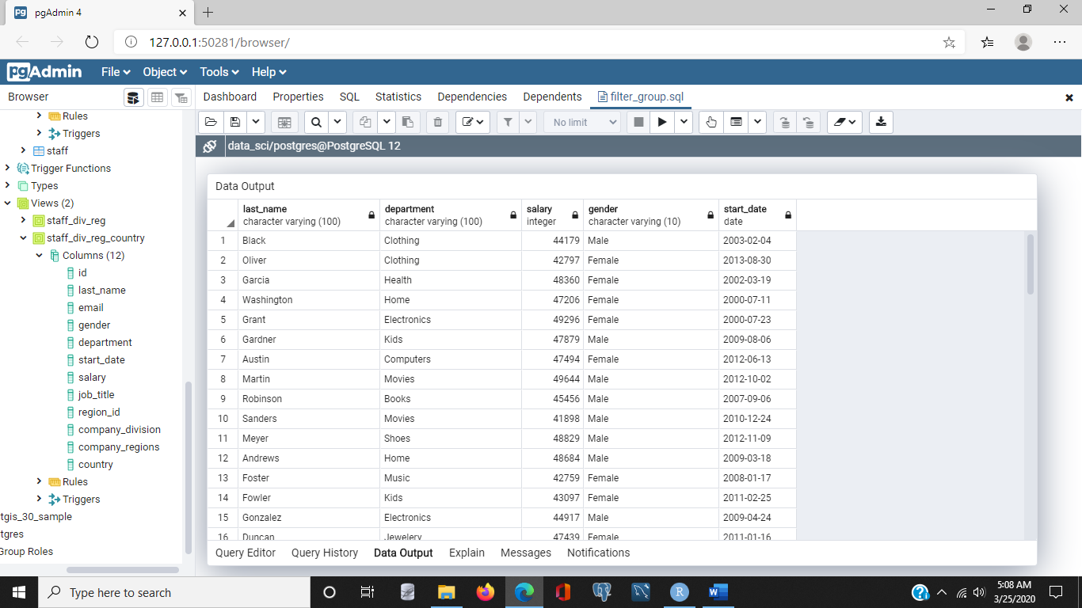

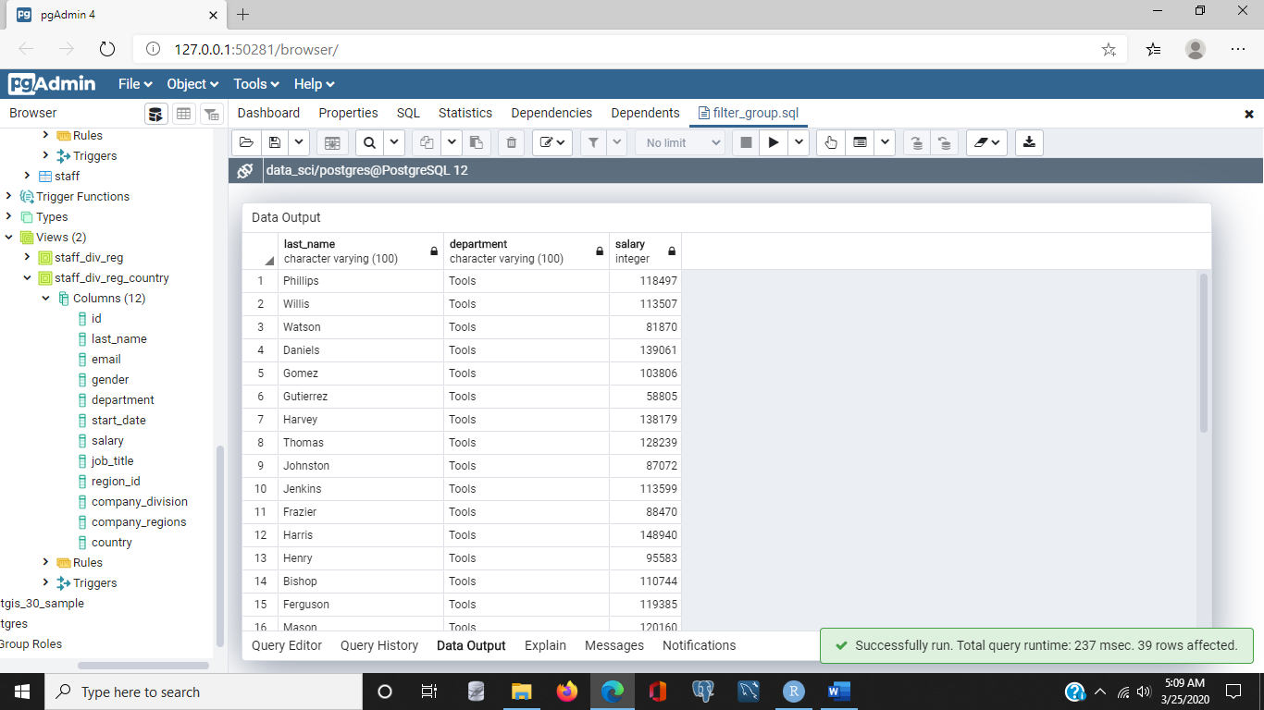/* Filter based on character values */

select

last_name, department, salary

from

staff

where

department = 'Tools';

/* Filter based on multiple attributes, all filters must be met*/

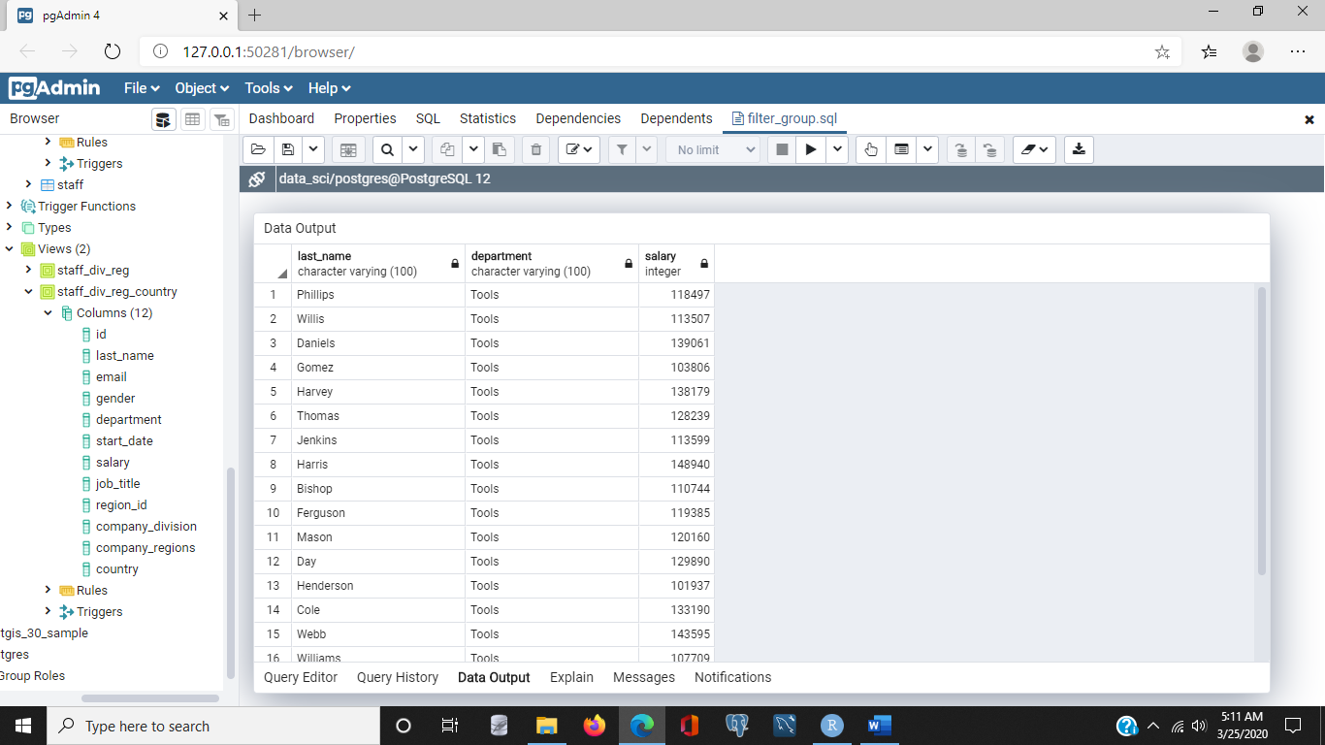select

last_name, department, salary

from

staff

where

department = 'Tools'

and

salary > 100000;

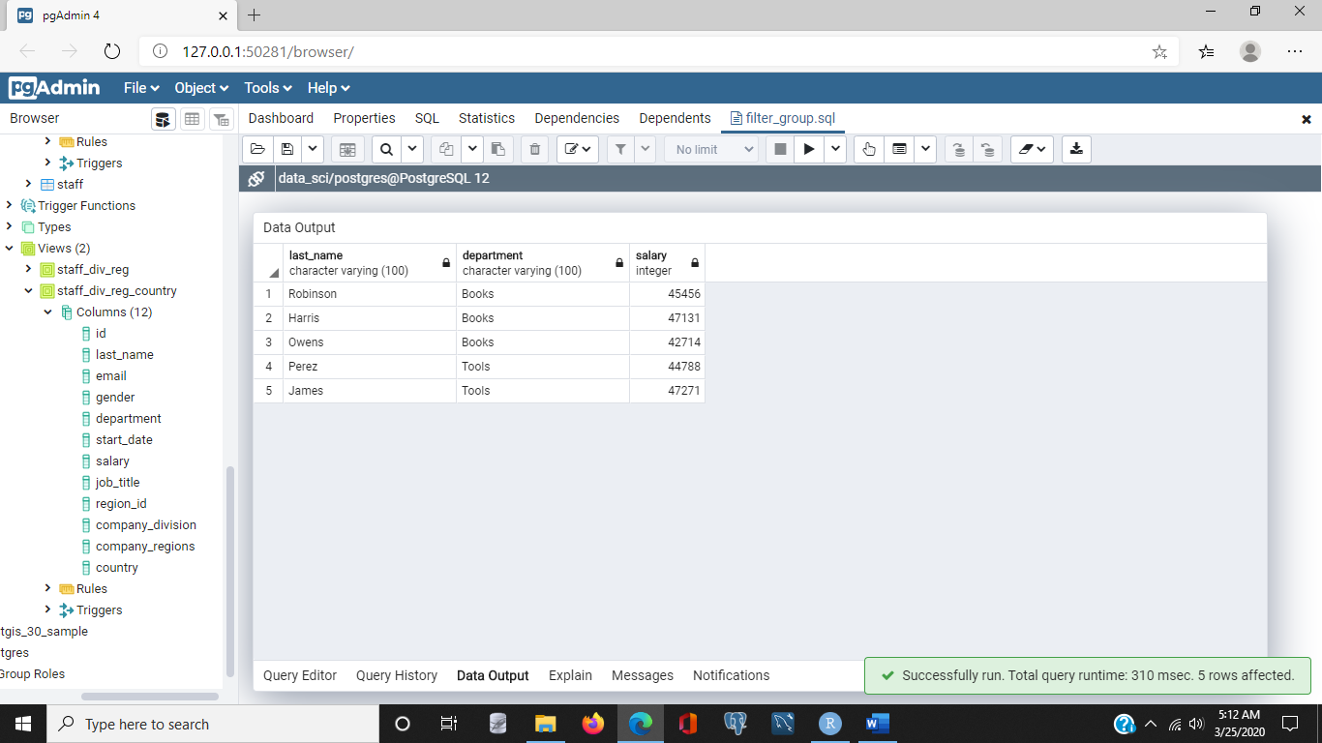/* Filter based on multiple attributes,

at least one filter must be met*/

select

last_name, department, salary

from

staff

where

department = 'Tools'

And salary <50000 and salary > 30000

or

department = 'Books'

And salary < 50000;

/* Filter based on patterns in character strings */

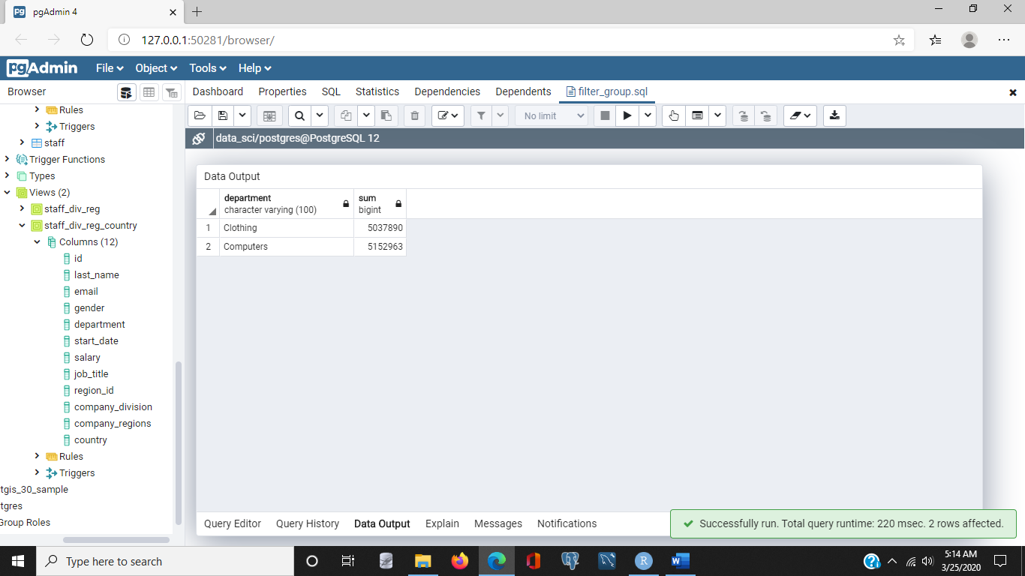select

department, sum(salary)

from

staff

where

department like 'C%'

group by

department;

/* Filter based on patterns in character strings */

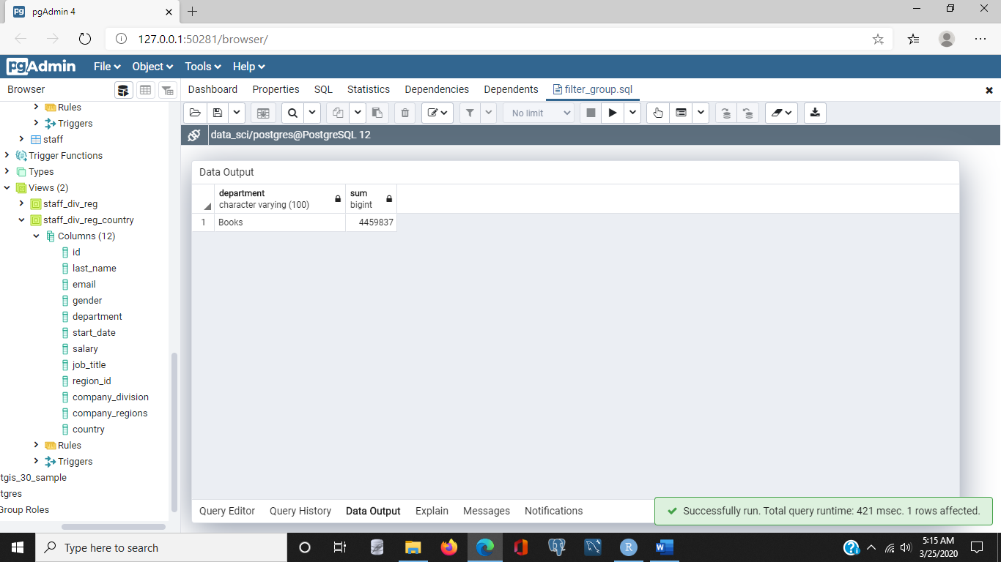select

department, sum(salary)

from

staff

where

department like 'Bo%' /*exact case match*/

group by

department;

/* Filter based on patterns in character strings */

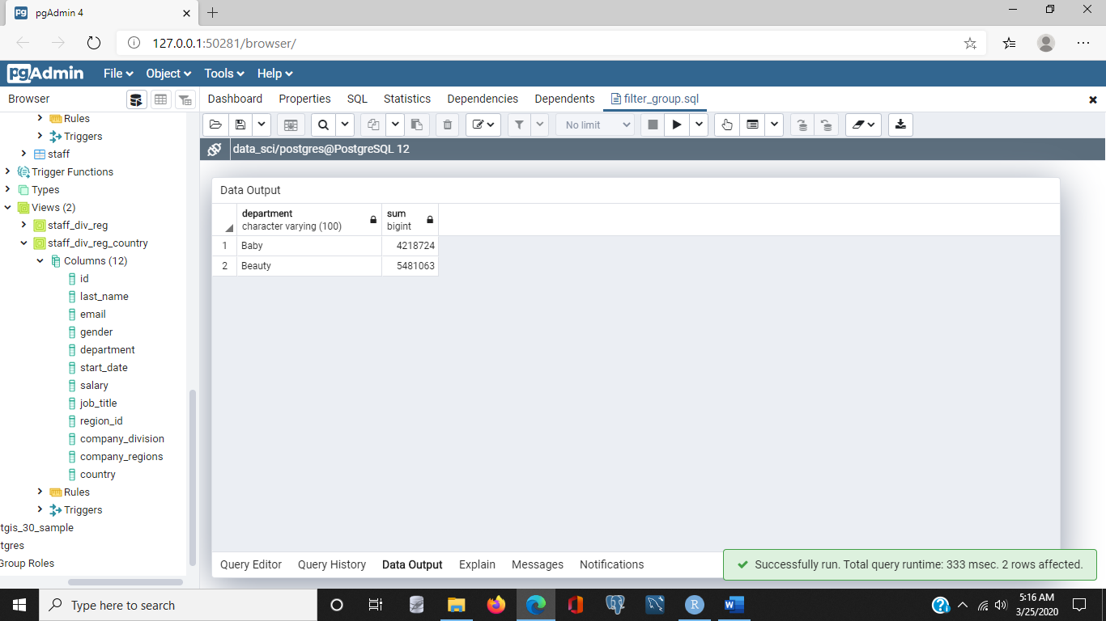select

department, sum(salary)

from

staff

where

department like 'B%y'

group by

department;

3. Data Munging with SQL

### Reformatting character data:03_01 file

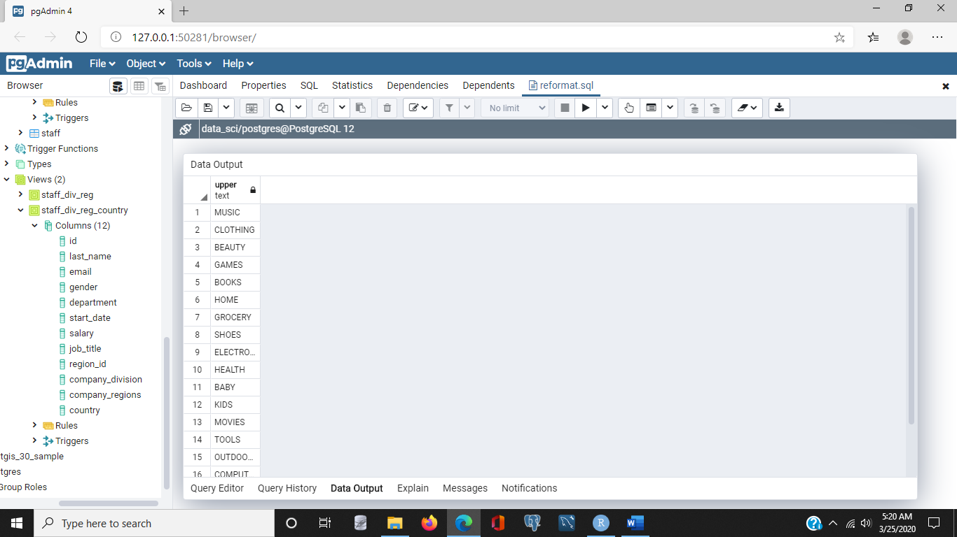- [Instructor] We often need to collect data from multiple sources. Sometimes, the same data is stored differently in different systems. For example, one database might use abbreviations for department names, while another database spells out the full name. We can reformat data to get it into a consistent format. Anytime you start working with a new data set, it is helpful to browse through the data to get a sense of how the data's formatted. So let's quickly look at how department names are stored in our database. Since we just need to see each name once, we'll use a distinct keyword. So we'll start with a SELECT statement, and we'll select department FROM staff, and as I'd mentioned, we want to use a DISTINCT keyword, so we'll put that in there. There, now we'll see each department once, and as you can see, we have a set of department names appearing as they are stored in the database. If we wanted to **reformat the department names to be in capitals or uppercase**,

select distinct

upper(department)

from

staff;

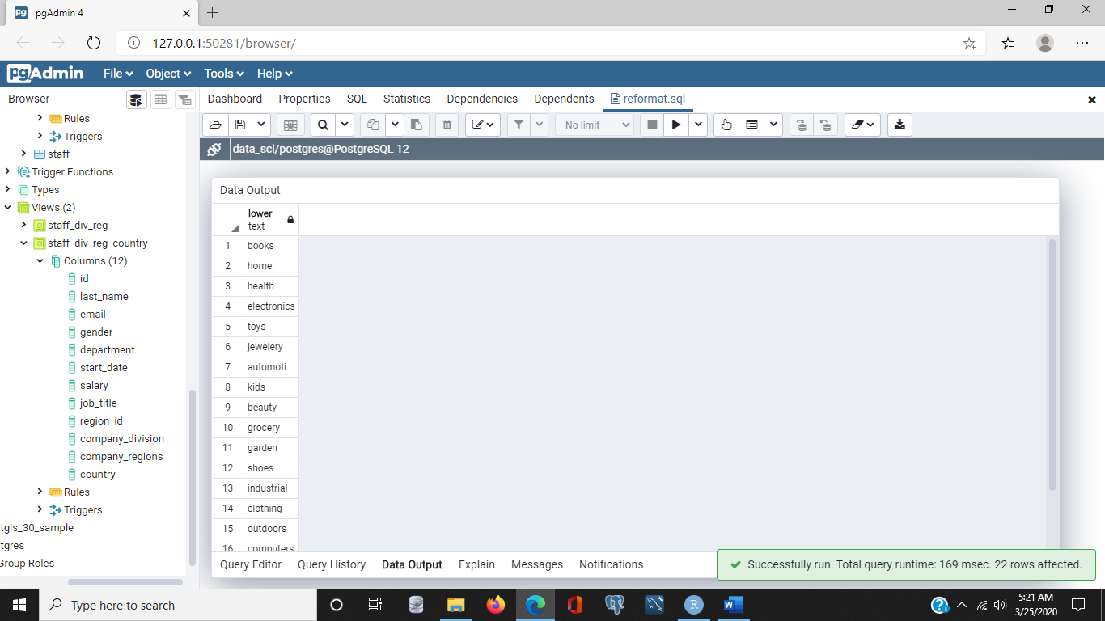

/* Convert the names of departments to lower case */

select distinct

lower(department)

from

staff;

we could use the UPPER keyword. And you'll notice the names are returned in uppercase. Similarly, if we wanted the department names in all lowercase, we'd use the LOWER keyword. Now, changing case is pretty simple. Sometimes, we might have data in two or more columns that we'd like to have in a single column. For example, if we want to have a job title combined with a department name, we could concatenate two columns. Let's do that. Let's select job_title, and we'll use the concatenation operator, which is two pipes,

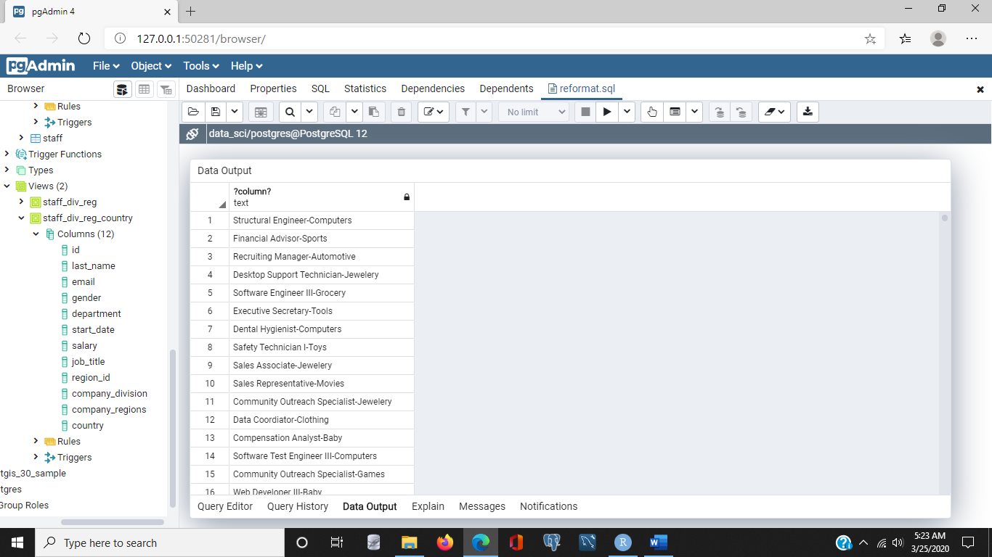select

job_title || '-' || department

from

staff;

and I want to put a dash in between the job title and the department name, so I'll concatenate that, and then I'll specify department, and we'll select this FROM staff. And what you'll notice is we have a job title followed by a dash, followed by the department name. Now, a nice feature of SQL is that was can give names to columns we create, such as when we reformat. Let's call this new column Title_Department, and I do that by placing the alias, title_department, and I'll abbreviate that as D-E-P-T, after the concatenation string. Now, when I execute, you'll notice the title is changed to title_department.

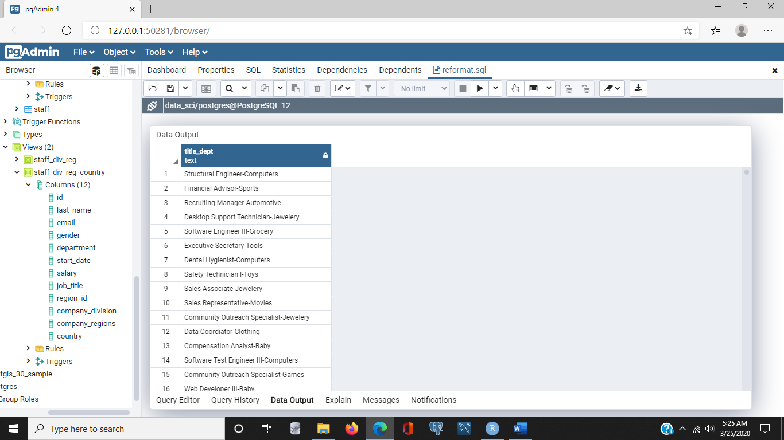

select

job_title || '-' || department title_dept

from

staff;

Depending on how data is stored in or extracted from other databases, you may find data has **extra white spaces**, like spaces and tabs. We can use the **trim function** to remove those extra characters. So, for example, let's just create a column here, and we'll select the trim of a string value that has some spaces in there. Let's call it Software Engineer, and we have a couple spaces in the front, so let's add a couple spaces at the end, and let's execute that statement. Now what happens is, we return just the value of the string without leaving or trailing white spaces. Now, let's just verify that we've actually cut off those spaces. Let's first check the length of the string. So, with the extra spaces, we have 21 characters.

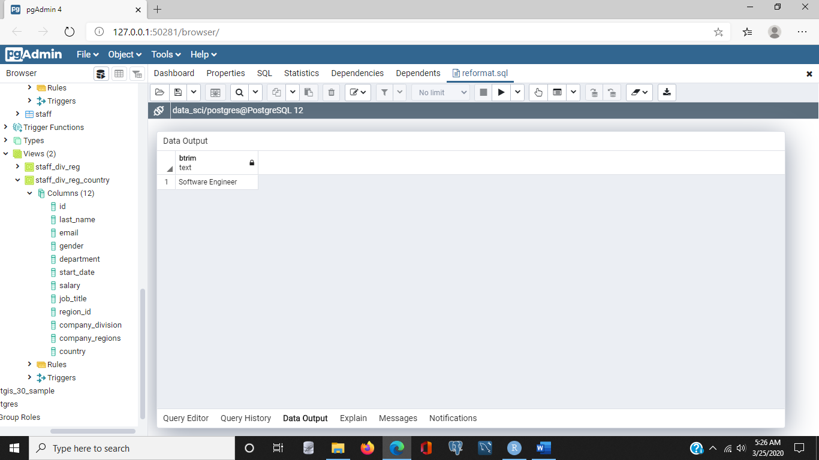Now, let's check the length after applying the trim function.

select

trim(' Software Engineer ');

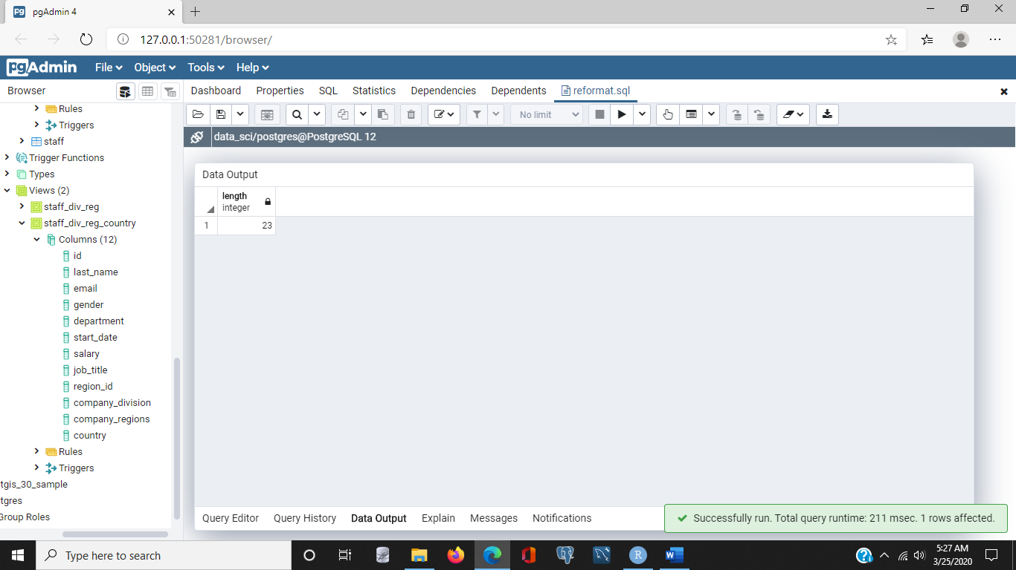

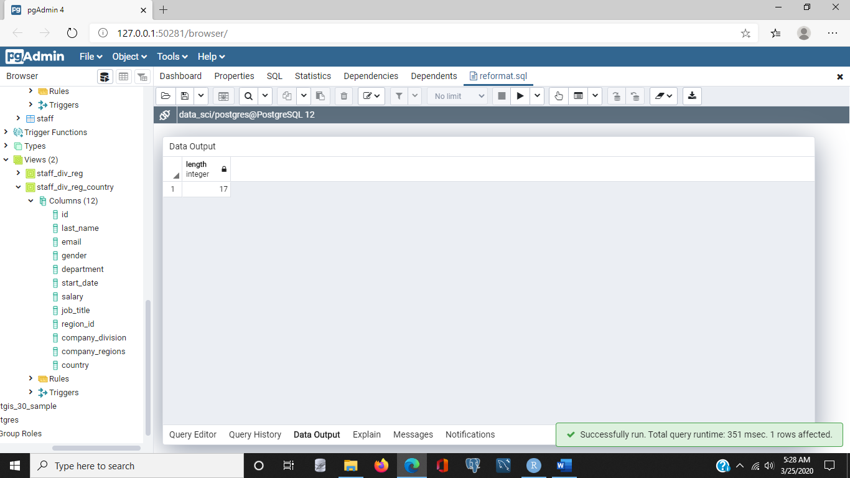

select

length(' Software Engineer ');

select

length(trim(' Software Engineer '));

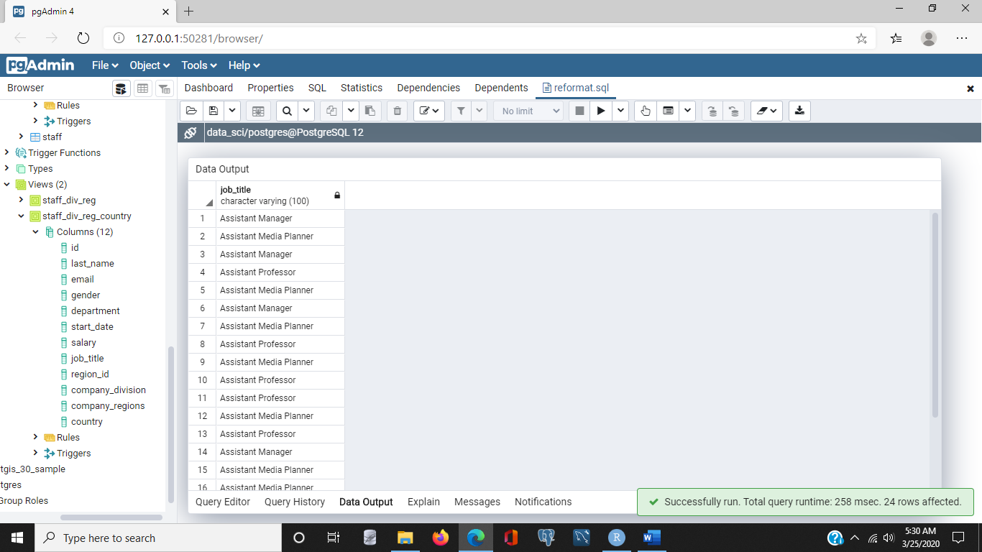Now, this should reduce it by the number of white spaces, and it is. So we drop about four white spaces there. Reformatting can also entail adding new types of information, such as category columns that make it easier to select rows that meet some criteria. For example, let's list all employees with a title that begins with the word Assistant. And to do that, we'll create a new SELECT statement, and we'll select job_title, FROM staff, WHERE job title is **like** Assistant, and we'll use the **wildcard**, and we'll execute, and we'll see a number of titles have the word Assistant in the beginning.

/* Show all job titles that start wtih Assistant */

select

job_title

from

staff

where

job_title like 'Assistant%'

/* Create a new **boolean** column indicating if a staff person has the term Assistant

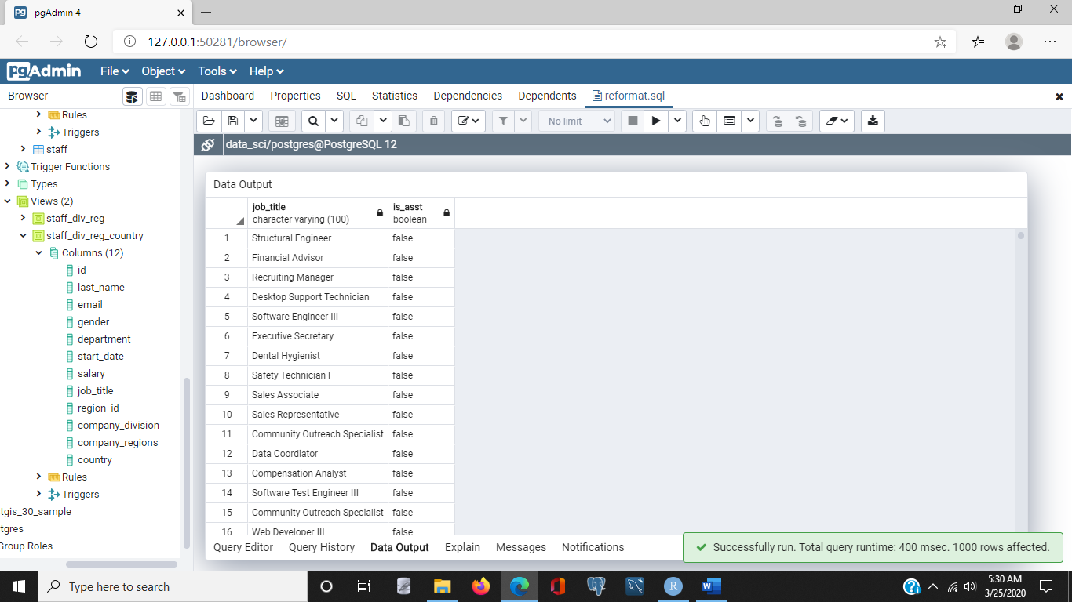 anywhere in their title. */

select

job_title, (job_title like '%Assistant%') is_asst

from

staff;

Now, we might want to make it obvious in a results set if someone is an assistant, so we can create a new **Boolean** column called Is Assist which will be true or false, depending on whether someone is actually in an assistant. So, let's select job title and let's put in a Boolean expression here. Job_title like, and actually, we'll put a wildcard in front as well as after the term Assistant, that way, if someone has the word Assistant in their title, but it's not in the beginning, we can still catch it. There. So, anytime a job title has the word Assistant in it, this Boolean will return true, and let's give it the name Is Assistant, which we'll abbreviate as Is_Asst, and we'll just execute it from the staff, and we'll do it for the entire staff, so we'll delete that where clause. Now what we find is that we have returned a value, Is_Asst, which is false when the word Assistant does not appear in the job title. But it is true, however, if, for example, we have Assistant Media Planner or Assistant Manager as the title. So that's one way of adding new columns that can make it easier for other people to filter without having to understand all of the logic that might go behind, determining whether or not someone is an assistant.

### Extracting strings from character data:03_02

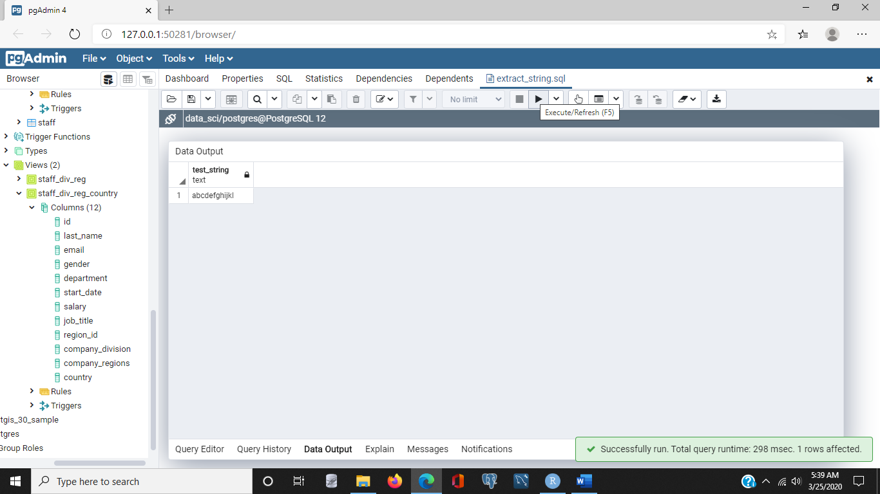- [Instructor] In addition to **matching** and **reformatting** strings, we sometimes need to take them apart and **extract** pieces of stings. SQL provides some general purpose functions for extracting and overriding strings. Let's start with a simple string that's easy to experiment. We'll use the first twelve letters of the alphabet, and I can do that by simply saying, SELECT, and then typing out the first 12 letters, and we'll call this test_string, and I can execute that, and we'll see I receive back a simple 12 character string. Now, one of the things we can do with SQL is replace parts of a string, and we can use, for example, the **substring** function. The substring function takes a string and a range, and returns the characters from the string that are in that range. So, I'll specify that I want to use the substring function, and I want to apply this to this 12 character string, and I want to specify that I want to start extracting from position one for a total of three characters, and if I execute this, I will see that I get three characters back, the first three. That makes sense. Ranges can start anywhere in the string. They don't have to start at the beginning. So, for example, I could start from position five, and go for three characters and extract, and get back the letters efg.

/* Use a string of 12 characters for experimenting with string extraction */

select

'abcdefghijkl' test_string;

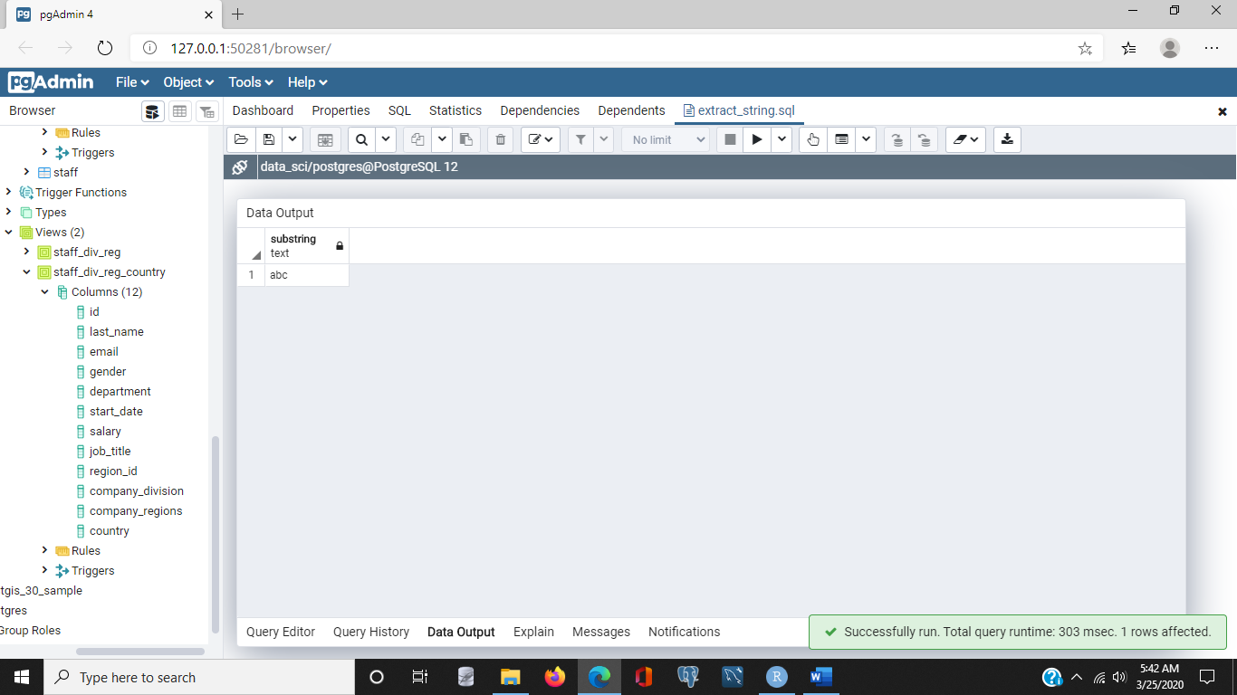

/* Select the first three characters of the string */

select

substring('abcdefghijkl' from 1 for 3) test_string;

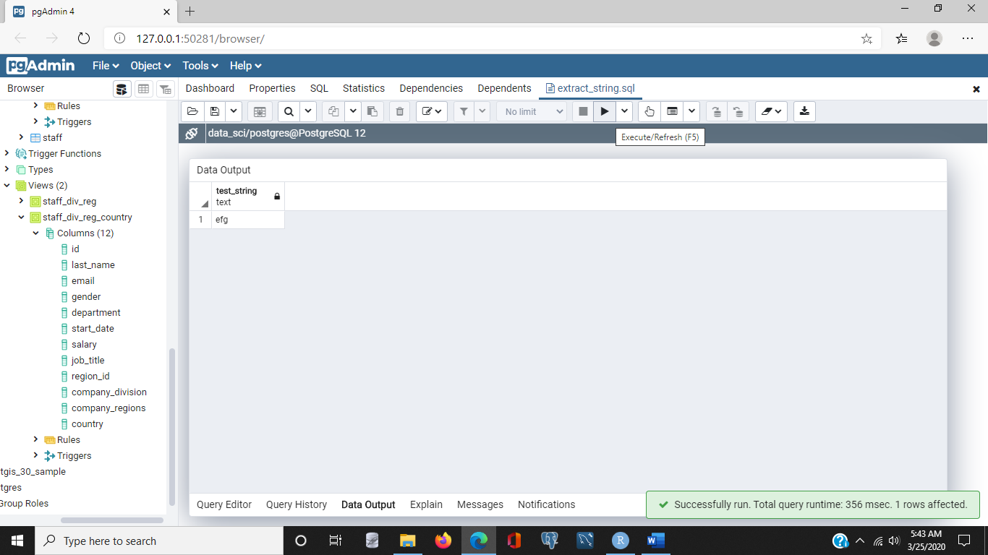

/* Select a subset from the middle of the string */

select

substring('abcdefghijkl' from 5 for 3) test_string;

Now, if you don't specify a length of a string to extract, the substring function will return the rest of the string starting at the position specified by the FROM keyword. So, for example, if we removed FOR 3, and I simply said, take the substring starting from position five, and I executed that statement, I would get all of the string starting at position five and going to the end. Okay, let's go back to working with our tables, and in particular, let's look at the job title column in the staff table. The assistant job title includes a main job category after the word Assistant. Let's see some examples. So, let's select job title FROM staff, WHERE job_title LIKE 'Assistant%', and what we'll notice is that assistant is the first word, and then there's another set of words like manager, media planner, or professor, these can act as a category, so if we wanted to extract the category, we could do that by noticing the word assistant is nine characters long, and there's a space after the word assistant. So, if we extract the job title starting at position 10, we should get back all of these categories. So, let's try that. So, I will select **SUBSTRING** of jobtitle FROM 10, and we'll execute that, and as expected, we get the words that follow assistant, such as manager, media planner, and professor. So that gives us what we expected. Now, **sometimes it's 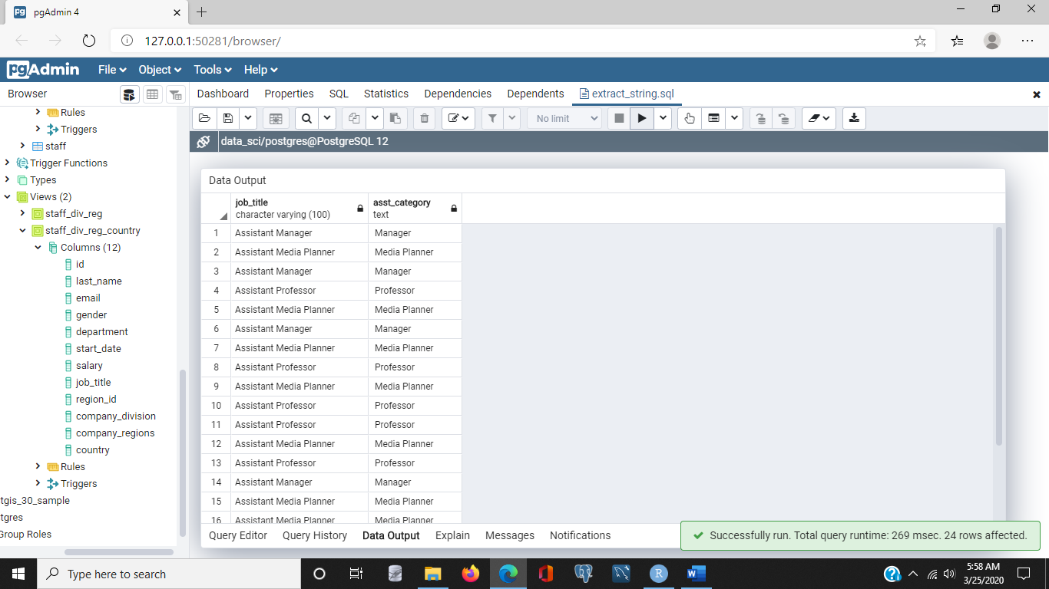useful to replace parts of a string.** We can do this with the **overlay function**. So, let's again keep it working with the job title. Let's say for example that we want to change the word assistant to an abbreviation like Asst, we can do that by replacing the full word with the abbreviation using the overlay function. So, let's change this to OVERLAY, and the overlay function takes the keyword PLACING, and we're going to place an abbreviation, in this case Asst., with whatever is in position from one, starting at one for 10 characters, and we'll do this only for job titles that are like Assistant%.

/* Change Assistant to Asst in job title */

select

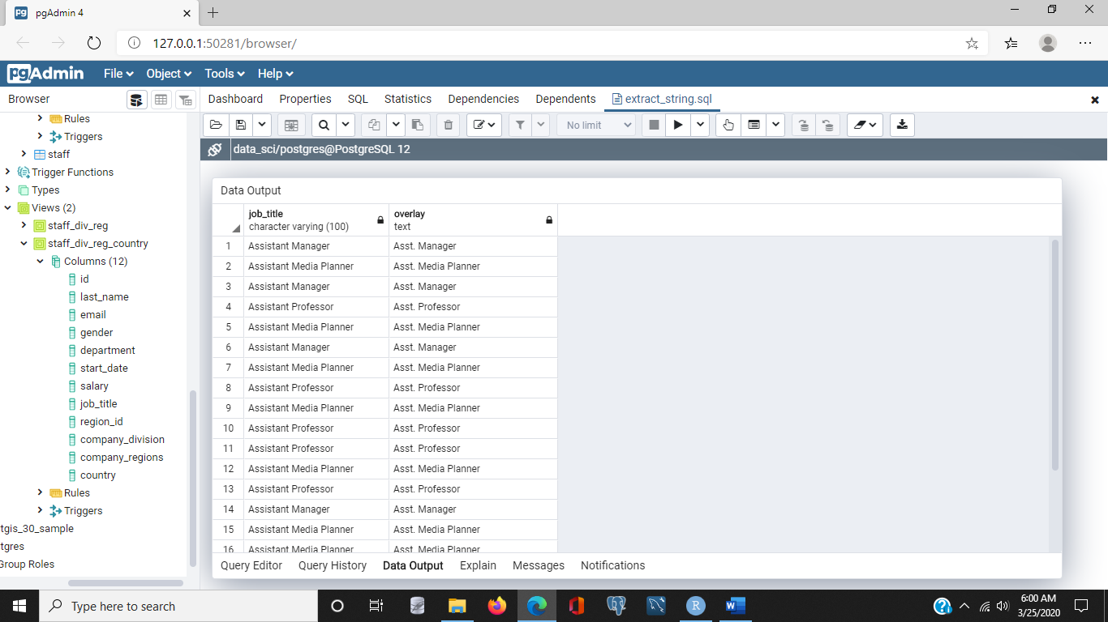 job_title, overlay(job_title placing 'Asst. ' from 1 for 10)

from

staff

where

job_title like 'Assistant%';

So, let's execute that. Now, what we'll notice here is that we have replaced Assistant with Asst., now, you'll also notice we lost the space. Now, why did that happen? That's because the word Assistant is nine characters long, we used 10 in previous examples because we wanted to include the space. In this case we don't want to overlay the space, so we need to change the length of the string we're replacing from 10 to length nine, and we'll execute again, and we'll notice that now we have what we would expect, the Assistant replaced by Asst, but we're not overriding the space. So, that's something important to watch out for as you're working with overlay in substring. It's very easy to commit what were called off by one errors, and this is just one example of those.

### Filtering with regular expressions:03_03 file

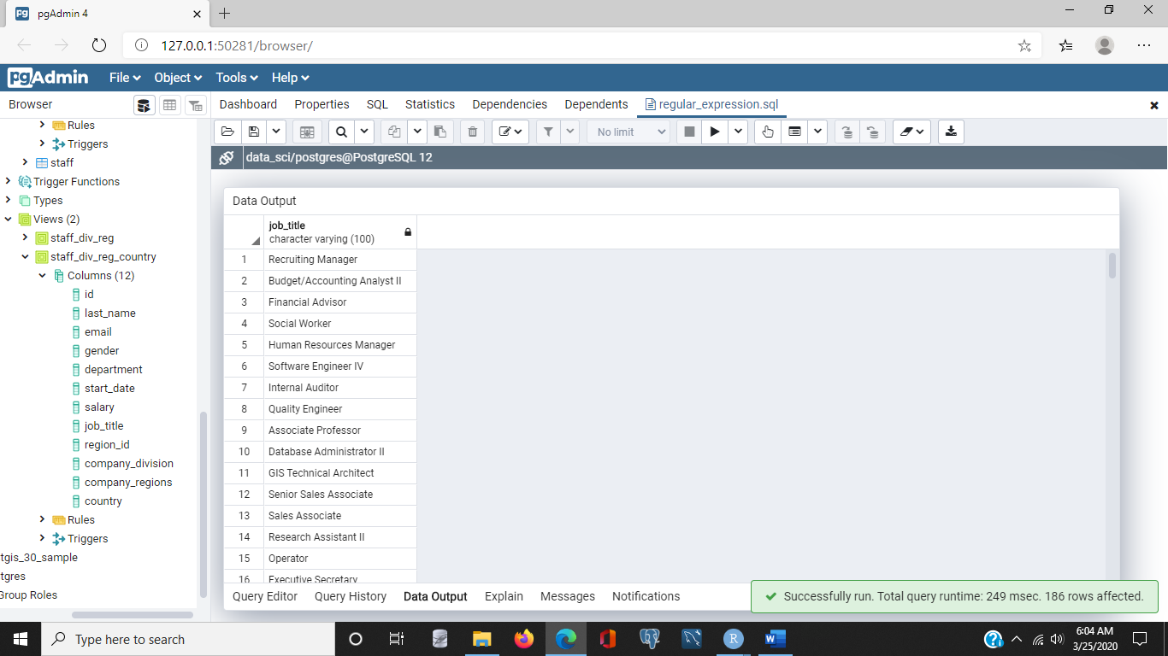- [Narrator**] Regular expressions** are patterns for describing how to match strings in a **WHERE** clause. Many programming languages support regular expressions that use slightly different syntax from what is used with the SQL **LIKE** operator. In this course, when we refer to regular expressions, we're referring to the patterns used with the SQL LIKE operator. Let's start by creating a list of job titles that have the word assistant in them. So to do that, we'll SELECT job_title from the staff table, WHERE job_title LIKE, and I want to search for the pattern where the word Assistant appears **anywhere** in the job title. So I'll put **% wildcards** **before and after** the word assistant. Then when we execute, you'll notice we have some titles where the word assistant is at the end, and some where the word assistant is in the beginning, and some where it is in the middle. Now, we'll notice there are different levels of assistant. Let's select just assistants at levels three or four. To do that, we're going to change the LIKE operator to the **SIMILAR TO** operator, because that has slightly more expressive syntax.

select distinct

job_title

from

staff

where

job_title **similar to** '%Assistant%(I)*';/*returns ‘Assistant ‘ and ‘Assistant I’ */

Now I want to match anything that has the word assistant, and has **either the roman numeral III or the roman numeral IV** and to do that, I create a list, and within that list, I list the patterns I want to match, in this case roman numeral III or roman numeral IV, and I separate them with the or character, or the pipe. Now let's execute and see what happens. These results are all either an assistant at level four, or an assistant at level three.

select distinct

job_title

from

staff

where

job_title similar to '%Assistant%(II|IV)'; /* ‘Assistant II’, ‘Assistant III’, and ‘Assistant IV returned */

Now we can also select a list of jobs that includes the assistant three, four, or any other two characters starting with the letter I. We do this by using the **underscore symbol**, which matches any **one** character. So I'm going to change the list with roman numeral III, and roman numeral IV, and instead, I'm going to look for assistant, followed by roman numeral I, and then any other roman numeral. This will match assistant two, or assistant four. And, as expected, all of the job titles listed, include the roman numeral IV or the roman numeral II.

select distinct

job_title

from

staff

where

job_title similar to '%Assistant I_'; /* returns only I or IV after Assistant */

Now, regular expressions can also be used to **match on a list of characters**. For example, we can use **square brackets** to specify a list of characters, any of which can match. For example, let's look at a pattern for matching any jobs that begin with the letter E, P, or S. We'll use the **SIMILAR TO** clause, and we'll list the characters we're interested in, E, P, and S in square brackets, and then that can be followed by any number of characters, so we use a **percent sign**, and we execute, and here again, we see that all of the job titles start with an S, a P, or E.

select distinct

job_title

from

staff

where

job_title similar to '[EPS]%';

### Reformatting numeric data:03_04 file

- [Instructor] Sometimes we will need to **reformat numbers**. This is especially true when we use calculations that have results with large numbers of decimal digits. For example, when we calculate the average salary by department, we will get a default format which produces more digits than really are necessary. Let's see that for an example. We'll select departments and the average salary. We'll select this from the staff table, and because we're using an aggregate function, in this case the average, we're going to want to make sure we have a group by statement, and in this case, we're going to group by department. When we execute this, we'll see we get a department list, and for each department, we have an average. Typically we would expect to see two decimal places when we're dealing with currencies, but in this case, we get more than is needed. There are a few different ways we can address this. If we're only interested in working with whole dollar amounts, then one option is to use the **truncate function**, or **trunc.** It truncates, or drops, the decimal portion of the number. Now I just want to point out that the truncate function, or trunc, does not round. It just ignores the decimal value. So let's add a column that truncates, or truncs, the average salary. Now we'll notice that, as expected, the decimal portion is truncated, or dropped. Now if we want to **round** to the nearest dollar when averaging salary, we should use the **round function**. Notice sometimes the truncated value is the same as the rounded, and sometimes it's not, so let's see that. Let's replace trunc with round and execute that. We'll notice the rounding sometimes rounds up and sometimes rounds down.

select

department, avg(salary), trunc(avg(salary)), round(avg(salary))

from

staff

group by

department;

If we would like to always return the next larger integer, so sort of the opposite of trunc, you could use the **ceiling function** which is **ceil**, C-E-I-L. If the decimal part of the number is greater than zero, then the ceiling function returns the next integer up in size, so let's try that. Let's replace round with the ceiling function and execute. We'll notice that the numeric value returned by the ceiling is always the next larger integer.

select

department, avg(salary), trunc(avg(salary)), ceil(avg(salary))

from

staff

group by

department;

When working with currencies, we often want to use two decimal places. We can use the round function for this. Round takes an optional parameter indicating how many digits to have after the decimal point. For example if we said round the average salary and return two decimal places, we would, as expected, have the number rounded to two decimal places. Sometimes this will round up to a larger number, and sometimes it'll round down to the smaller number, but it always rounds to the decimal point that you indicate using that optional parameter. Similarly, trunc which is used for truncating can also take an optional number of decimal places, so let's just add that. **Trunc of the average salary, and let's specify that to two decimal places**, and we'll execute, and once again we'll notice that sometimes trunc will be the same, and sometimes it won't. Now both the round and the trunc functions can be used to truncate or round to a variable number of decimal places. It doesn't have to be two, so let's round to three decimal places and truncate to four decimal places and see what that looks like. Again, we have three decimal places in the case of the round function and four decimal places in the case of the trunc function. The exception being if the final digit is zero, it can be dropped.

/* Both round and trunc can be used to truncate to a variable number of decimal places */

select

department, avg(salary), round(avg(salary), 3), trunc(avg(salary), 4)

from

staff

group by

department;

4. Filtering, Joining, and Aggregation

### Subqueries in SELECT clauses:04_01 file

- [Narrator] We usually select data directly from tables and views but sometimes it's helpful to be able to get data from the results of another select statement. Now we can do this using what are called **Sub Queries**. Sub Queries can be used in **three different parts of a select statement**. In the **list of values returned**, in the **From Clause** and in the **Where Clause**. Let's work through an example of each of these three. We'll do the first in this video. Let's start by building a basic query. So let's select oh the last name, the salary, and the department from the staff table. Now, because we'll have multiple select statements within a single query we'll want to make sure the database can tell which table each value comes from. So to do this, we'll use a **table alias** and include that alias as a prefix for each value we'll return. I'll assign an alias of S1 to the staff table and add S1 as a prefix to each column I want to return from that table. Now when we execute this, we'll get the data we expect. Last names, salaries, and department names. Now, in addition to the last name, salary, and department, I'd like to include the average salary for each of those departments. This will let us easily compare a person's salary with the average for their department. Now to do that we'll use a **Sub Query that calculates the average salary for the department that matches the department of the employee's row**. So to do that I'm going to add another value here but instead of the value coming from the table it's going to come from a select statement. And I will select the average salary. Now average can return a lot a decimal points so I'm going to actually round that to the nearest dollar and I'm going to select the salary or the average salary from the staff table. Now I've already mentioned staff table once and have an alias for it. So I'm going to use a different alias to indicate that I'm talking about it, sort of a different reference to the staff table. And the other thing I want to do is make sure that I include in the average just the salaries for the department that I'm working with. And to do that I'll say anytime I refer to the department for S2, I want that department to be the same as the department that's listed up above in S1. Let's take a step back and look at this. We have our **outer query** which includes a last name, a salary, and a department. And then we have this **inner query** or **sub query** that calculates the average salary from the staff table but only using rows where the department is equal to the department of the employee we're currently looking at. So that's how the sub query works and we'll execute this statement. And we'll see now that we've added an extra column. This column lists the average salary for the corresponding department, which in the first row is computers. The second row is sports, third is automotive and so on. The important thing to note is that **we use a sub query where we'd usually use a column name.** Now within that sub query, we need a **Where Clause that references a table in the top level query so that the sub query knows which row is referenced**.

/* Include department's average salary in each row with staff */

/* Use an alias on table names so that one table can be queried in */

/* subqueries and top level queries */

select

s1.last_name,

s1.salary,

s1.department,

(select round(avg(salary)) from staff s2 where s1.department = s2.department) dept_avg

from

staff s1;

### Subqueries in FROM clauses:04_01 file

- [Instructor] Let's look at another example of how to use subqueries. Assume that anyone who earns more than $100,000 per year is an executive. And that we'd like to find the average executive salary by department. We can do this by creating a subquery that returns the department and the salary of executives only. We then group by department and average the salaries of those executives. So let's start by building the subquery. We'll select and we want to be able to select a department and a salary. We want to select this from the staff table. Now we want to limit this to executives so we'll have a where clause that says where salary is greater than $100,000. Now I'm going to turn this into a **subquery** so I'll **wrap it** in parentheses and I want to make sure I give it an alias. So I'll call this S-one. Now I want to treat that almost like a table. I want to select from this, I want to select the department, include the alias in that, and I want to select the average salary. Select the average of the salary. Now again average sometimes returns a large number of decimal points, so I'm going to use the round function to round to the nearest dollar. And I want to select the department and the average salary from this query, this set of data about executives. So I'm going to indent a little bit just to make it obvious that this is a subquery. Now what you'll notice is the subquery has been labeled S-one, and I'm selecting from it because I'm referencing S-one up above. I am using an aggregate function and I do want to group by department so I'm going to include that as well. And of course I want to include the alias.

/* Select columns from a subquery instead of a table */

/* Find the average of executive salaries, defined as salaries > 100,000 */

select

department,

round(avg(salary))

from

(select

s2.department,

s2.salary

from

staff s2

where

salary > 100000) s1

group by

department;

There, now when we execute, what we find is we get a list of departments as expected, we get an average salary, but we'll notice all of the average salaries are above $100,000. Well above, and that indicates that we are on the right track. We have selected the salary of only executives and those are people that make more than $100,000 and we've done that by using a sub-select statement. The important thing to note here is that **we can use a subquery where we usually use a table name in the FROM clause.**

### Subqueries in WHERE clauses:04_01 file

- [Male Voice] We can use subqueries in where clauses. These are **useful when we want to make comparisons within a single table**. For example, if we want to find the department of the person with the highest salary, we can use a subquery in the where clause that finds the maximum salary of all staff. Let's start by building the subquery. We want to select maximum or max salary from the staff table. Now, because we're working with **subqueries**, we want to make sure we use an **alias**, so I'll assign this the **alias s2,** and I'll make sure that **I reference s2** above and it's a **subquery so I will wrap this in parentheses**. So now I have a subquery that returns the **maximum salary** that is listed in the staff table. Now I want to build out the rest of my query, which is to **select the department** from the staff table, and I'll use **s1 as the reference** there, where the salary in s1 is equal to this maximum salary. So I'll move things around a little bit to make it obvious what I'm doing here. So what I'm doing is I have a subquery, which finds the maximum salary in the staff table. I then have a **top level** query which returns the department for whatever row has a salary that is equal to the maximum salary. Now instead of just showing the department name, let's show the last name and the salary. Now, of course, I want to include the aliases. So there. So this will show us the department, the last name and the salary of the person in the staff table who makes the maximum salary. So it turns out to be somebody named Stanley who works in the grocery department and makes almost $150,000 a year. So that's an example of how to use the subquery in a where clause.

select

s1.department, s1.salary, s1.last_name

from

staff s1

where

(select max(salary) from staff s2) = salary;

### Joining tables:04_04 file

- [Narrator] When working with SQL, we will sometimes need to retrieve data from multiple tables. For example, the Staff table includes a department for each employee. Departments are organized into divisions. Since we don't keep division information in the staff table, we have to look it up somewhere else. In our example data set, we have a table called Company Divisions. Let's take a look at that. We'll do that by typing Select + *, to get all the columns From, company divisions and that's plural. And when we execute it, we'll notice that first of all, 21 rows are returned and the table has two columns. One listed departments that we are familiar with, we've seen those before. And the other column lists a higher level grouping or division. Which include things like Auto and Hardware, Domestic and Electronic Equipment. Now, let's join the Staff and Company Divisions tables. So, let's replace the Select + * with a Select. Oh, let's select from the Staff table a last name and a department and let's from the Company Divisions table let's select Company Division. Now we'll have to do this from two tables, from the Staff table and the Company Divisions table. And I'll make sure I alias both of those. Now, to join these, I need to use the **Join** keyword. And so now I'm joining the Staff table to the Company Division and I have to specify which columns to look at to join. And to do that, I specify the **On** keyword and from the Staff table, I want to look at Department. And similarly, from the Company Divisions table, I want to look at the Department, as well. So, when the departments are equal in both cases, then we join those rows. So again, this Select statement, chooses two columns from the Staff table, one column from the Company Divisions table and it joins using the Department columns in both. And when we execute, we get these results. So we have the last name and the department from the Staff table and the company division from the Company Division table.

/* Join staff and department. If the staff department is not found in */

/* company_divisions, then no row will be returned. */

select

s.last_name, s.department, cd.company_division

from

staff s

join

company_divisions cd

on

s.department = cd.department;

Now, I'm going to execute this query again and point out that 953 rows were returned. Now, there are 1000 rows in the Staff table. So something has not gone right here. How did we lose 47 rows? What we want to do now, if we want to return all rows in the Staff table, even when no corresponding row is found in the Company Divisions table, then we use an outer join to return all rows. And that's what we want to do here because for some reason, 47 rows were not returned. Now, **outer joins** can either be **left** outer joins or **right** outer joins. And that has to do with **the ordering of the tables in the join statement**. We're going to use a left outer join because that will return all rows from the table referenced on the left side of the keyword. I'm going to make this a little explicit and put the join on the same line as the two tables that we're working with. And now I'm going to change this join to a left join and this says select these three columns we've specified, Last Name, Department and Company Division from the Staff table, left join to the Company Divisions table. Again, by left joining we're going to take all of the rows in the Staff table, even if there isn't a corresponding row in the Company Divisions table.

select

s.last_name, s.department, cd.company_division

from

staff s

left join

company_divisions cd

on

s.department = cd.department;

So, let's execute that. We have 1000 rows that were returned in this case. We have some rows in this result set that don't have a company division. So, let's find out where those are. Let's select Where Company Division is null. Which is how SQL indicates there is no value for a column.

/* The previous query did not return 1,000 rows. What rows are missing? */

select distinct

department

from

staff

where

department not in

(select

department

from

company_divisions);

And what we notice here is, we have 47 rows returned, as expected. They're all from the Books department so it must be the case that Books is not included in the Company Divisions table.

### Creating a view:04_05 file

- [Narrator] We can **group data** in a variety of ways using Sequel. Now we'll be working with data from the staff, company divisions and company regions table. So let's create a view using a select statement with the appropriate joins. This will save us from having to type long joined statements repeatedly. So lets start by defining the select statement that we want. So I'll start by saying, select. I want to select all of the columns from the staff table. And I want to select company division. And I want to select company region, and I want to select this from the staff table, which we'll alias as s. And, we'll left join on the company divisions table, and we'll do this on the staff table department. And, company divisions department. And we'll left join company regions. On, staff, region id and the company regions. Region id. And before I run this, it looks like I missed the s at the end of the cr.company_regions column. And, what we have here is a select statement that uses two left joins and it selects all the rows from the staff table, it selects the company division, and the company regions name. And, it returns them all as a single table. So, rather than re-typing this select statement every time we need this combination of these three tables, we can simply **create a view** and we do that by issuing the command, create, view, and let's give it a name, we'll call this, staff_div_reg AS. So now, we're able to specify a view which we will call, staff_div_reg. And it will be associated with this select statement that we just created. So if I execute this command, instead of getting the results returned, I actually create the view. And so that view has been created as the message implies. Now, let's just do a quick double check and make sure everything worked as expected. So we'll clear this out, and now what I want to do, is I want to select, count(*), from that view I just created. So I'm going to select it FROM staff_div_reg, and if all goes well, we will have a thousand returned, and we do. So all thousand rows in the staff table, have been joined to company regions and company divisions, and now we have a view that we can work with.

/* Create a view to minimize the amount of typing and reduce the risk of making a mistake */

create view staff_div_reg as

select

s.*, cd.company_division, cr.company_regions

from

staff s

left join

company_divisions cd

on

s.department = cd.department

left join

company_regions cr

on

s.region_id = cr.region_id;

/* Verify the view has 1,000 rows */

select

count(*)

from

staff_div_reg;

### Grouping and totaling:04_05 file

- [Instructor] Let's use the view we just created to get a count of the number of employees in each region. So we'll enter a SELECT query and let's select the company region and let's get a count of company regions. And we'll get this from our view, staff_div_reg, now we're aggregating, we're using a count, so we'll have to have a GROUP BY statement, and in this case we'll want to group by company region. Let's add an ORDER BY so we get the company region counts listed alphabetically.

/* Add an order by clause to make it easier to read */

select

company_division, company_regions, count(*)

from

staff_div_reg

group by

company_division, company_regions

order by

company_regions, company_division;

And I'll execute, and we'll notice we have our list of seven regions, with a count of the number of staff in each. Now if we want counts by both region and division, we can use a feature called **grouping sets**. Here, let's look at an example that returns employee counts by division and by region. So the first thing I'll do is I will add company division to my list of columns that I'm returning. **In the GROUP BY clause, I'm going to add the phrase, grouping sets, and then I'm going to give it a list of columns that I would like to group by**. Well I'd like to group by company division, and by company region, so I'll close the list. Now I've also added company division to the list of columns that I returned so I'll want to be sure to include that in my ORDER BY clause. Now let's execute and see the results.

/* Get employee counts by division and by region */

select

company_division, company_regions, count(*)

from

staff_div_reg

group by

grouping sets (company_division, company_regions)

order by

company_regions, company_division;

Now what you'll notice here is we still get our seven company regions, those are listed first, but we also get totals by company division, those are the next set. Now we'll notice one of these down at the bottom has no name for company division**, that's because the books department didn't have a corresponding division.** Now let's just add in gender just to generate some additional results. So to do that, I'll add gender to my list of columns that I want to return. And I will add it to my list that follows the phrase grouping sets. And of course I'll want it in the ORDER BY clause.

/* Now, add in gender to break down even further */

/* Get employee counts by division and by region */

/* There are null values in all columns, but the relevant fields have values */

select

company_division, company_regions, gender, count(*)

from

staff_div_reg

group by

grouping sets (company_division, company_regions, gender)

order by

company_regions, company_division, gender;

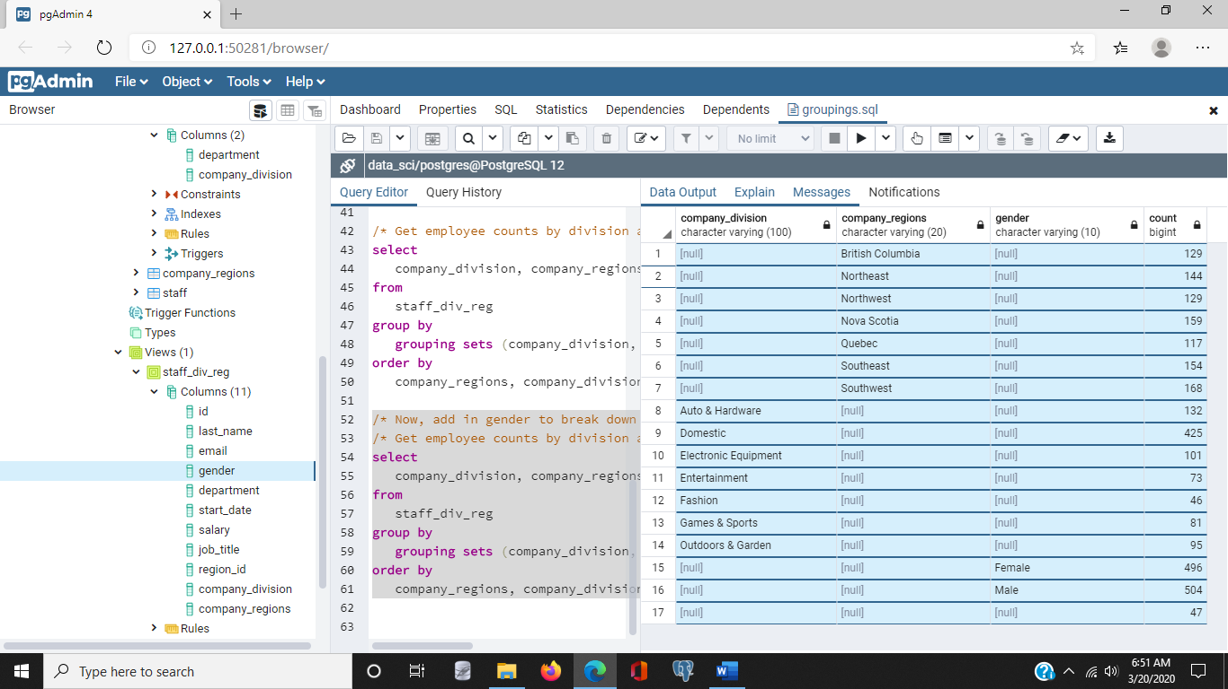

And now we'll notice again the first set of results is the seven company regions, followed by company divisions, followed by gender.

### ROLLUP and CUBE to create subtotals:04_07 file

- [Instructor] Let's continue our look at ways to **group and aggregate** data with two other operators**, ROLLUPs and CUBEs**. Now first, let's modify the staff division region view we created to include country code. To do that, I'm going to use the command **CREATE** **OR** **REPLACE VIEW**, and as the name implies, if this view doesn't exist, it will simply create it. If there is a version of this view that already exists, it'll replace that version with the version I'm about to specify. And we'll call this staff_div_reg_country, and we'll define this as the SELECT of all the columns in the staff table, plus company_division, company_regions, and country. And we'll select these columns FROM staff table, which we'll alias as s. And the staff table will LEFT JOIN to the company_divisions table, which we'll alias as cd, and that left join will be performed on department in both state and company_division. And then we'll take the results of that left join operation and apply another left join, this time to company_regions, and that will be on the staff table region_id, and the company_region's region_id.

/* create or replace view */

create or replace view staff_div_reg_country as

select

s.*, cd.company_division, cr.company_regions,cr.country

from

staff s

left join

company_divisions cd

on

s.department = cd.department

left join

company_regions cr

on

s.region_id = cr.region_id;

So, let's execute that to create that view. Now, let's select the number of employees by company, region, and country. So the first thing I would do is just clean up this. I'll remove the text that I had before to create the view, and I'll specify a SELECT statement. And what I want to select is company_regions, country, and then a count of those. And I'll get this from the view I just created, staff_div_reg_country. Now I have an aggregate of the count, so I'll need a GROUP BY statement, and I'm going to group by company_regions and country, and let's specify an ORDER BY clause. Let's order by country first, and then by company_regions.

/* Select nubmer of employees by company_region and country */

select

company_regions, country, count(*)

from

staff_div_reg_country

group by

company_regions, country

order by

country, company_regions

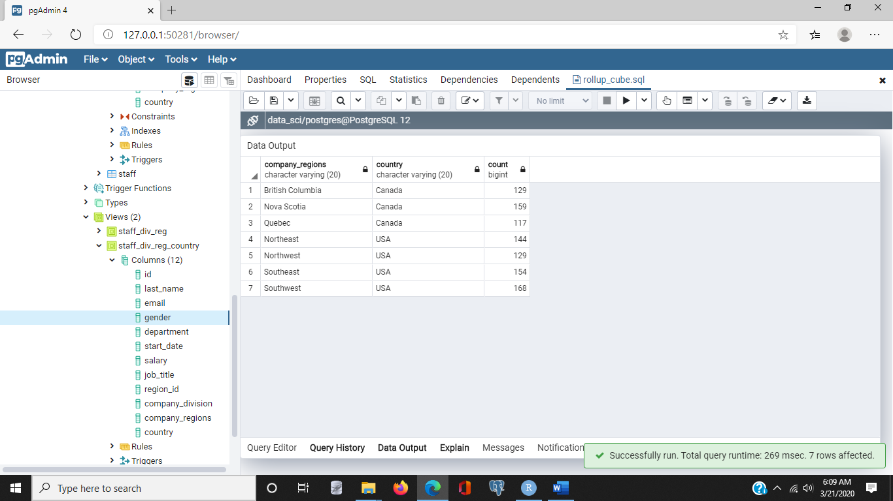

Now let's execute this SELECT. This shows the totals for each regions in each of the two countries.

Now, if we wanted to see the totals from each country as well, we can use the **ROLLUP operation on the GROUP BY clause**. This will calculate sums in the hierarchy for regions and countries. So, in the GROUP BY clause, we're going to specify ROLLUP, and we're going to rollup by country and then by company_regions.

/* Use rollup operation on the group by clause to create hierarchical sums */

select

company_regions, country, count(*)

from

staff_div_reg_country

group by

rollup (country, company_regions)

order by

country, company_regions

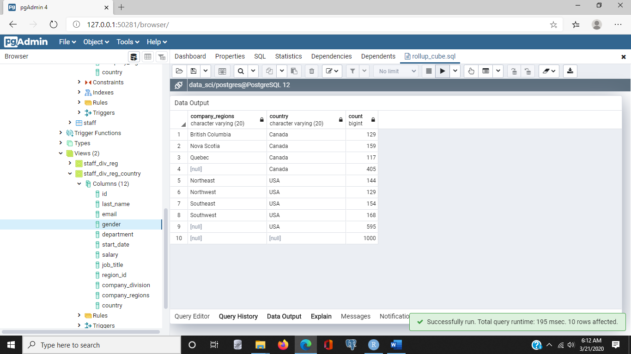

And so you see, for example, we have the total for Canada as well as the total for US and a total for both countries combined.

Now, for more advanced breakdowns, we can use the **CUBE** operation on the GROUP BY clause. This tells SQL to create all possible combinations of sets of grouping columns. For example, for each division, show results by region. So we will move the ORDER BY here and we'll remove ROLLUP, and we'll specify CUBE, and we're going to use not country, but we're going to use a cube of company_division. So I'll need to specify company_division here in the SELECT statement. So I'll have company_division, company_region, and count, but we no longer need country, so I'll remove that. So now, my SELECT statement is to select company_division and company_regions along with a count FROM the staff_div_reg_country view, and then apply the CUBE operation.

/* Use cube operation on the group by clause to create all possible combination of sets of grouping columns */

select

company_division, company_regions, count(*)

from

staff_div_reg_country

group by

cube (company_division, company_regions);

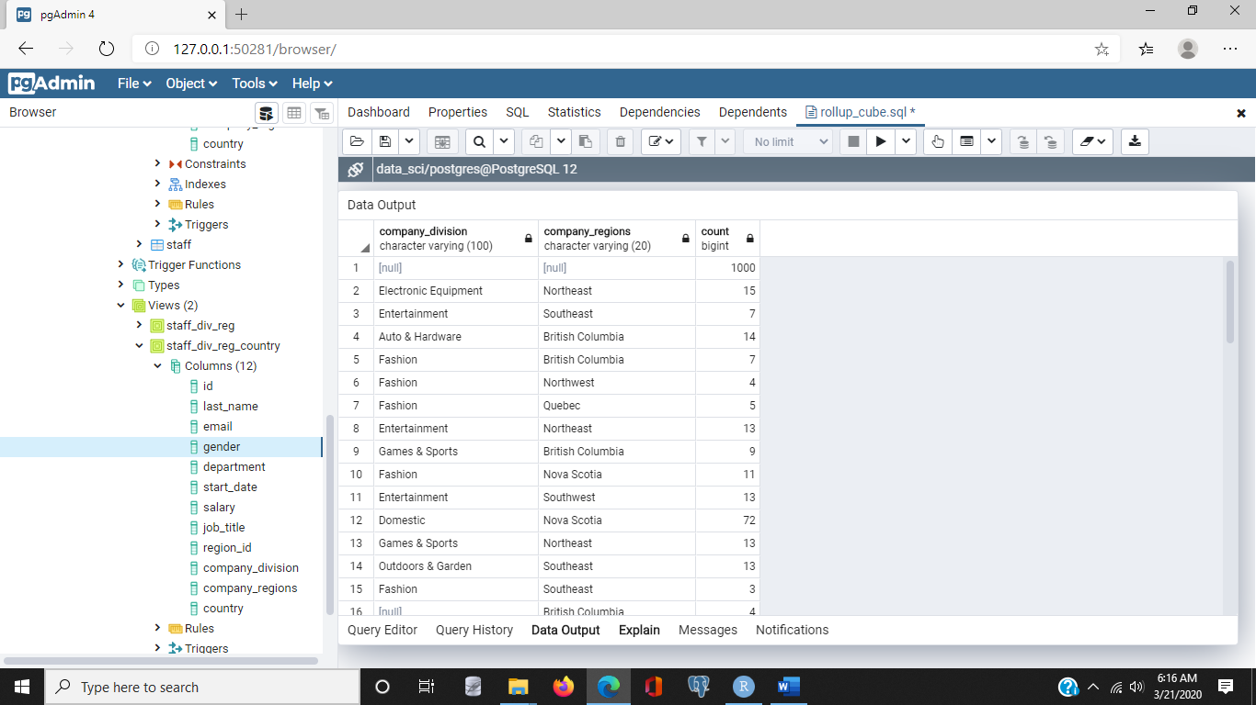

This shows totals by division and regions with totals by division.

### FETCH FIRST to find top results:04_08 file

- [Narrator] When working with large data sets, we're sometimes interested only in the top results, based on some sort criteria. For example, we might want to list the employees with the top 10 salaries. Let's see how easy it is to work with the top results in SQL. Now I'm going to build a select statement, and let's select the last name, job title, and salary. Let's pull this from the staff table, and we want to know about salary and top salaries, so we're going to order by salary, and we want the top salary, so we want to start at the highest so we'll use the descending, or **DESC** keyword. Now, what I'm going to do is add a clause called **fetch** first. Now, **fetch first works with the order by clause to sort and limit results.** Fetch first is like the limit keyword, in that only a fixed number of rows are returned, but **with fetch first, the ordering is performed before choosing the rows to return**. So, I'll specify fetch first, 10 rows only, so this will return only 10 rows. And as we'll see, there are 10 rows returned, and they're in descending order, by salary. An important point to remember is that fetch first works with the order by clause to sort the results before selecting the rows to return. This is different from the way the limit clause works. Limit actually limits the number of rows, and then performs the operations.

/* Use order by and fetch first to limit the number of rows returned */

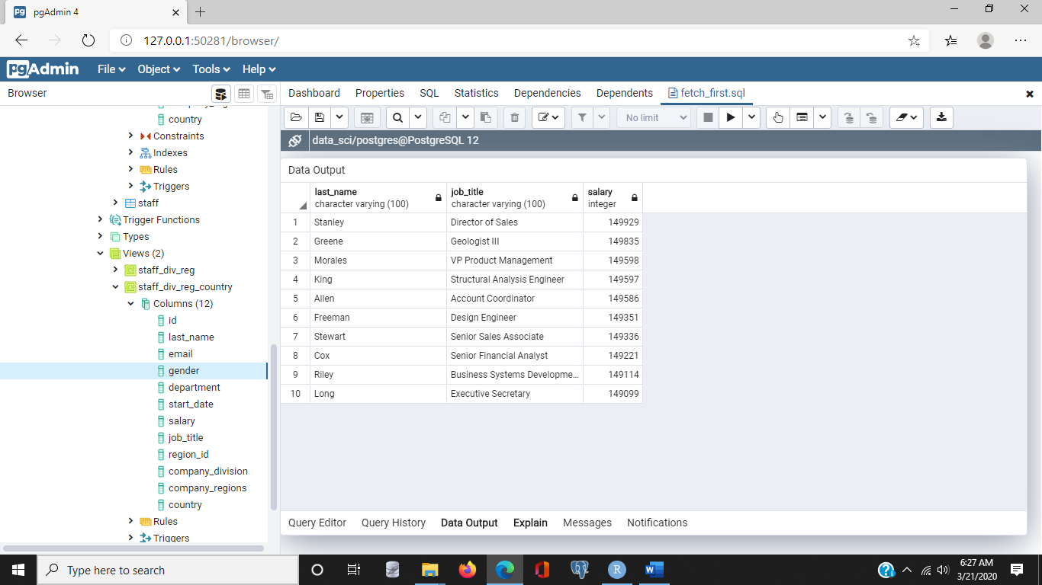select

last_name, job_title, salary

from

staff

order by

salary desc

fetch first

10 rows only;

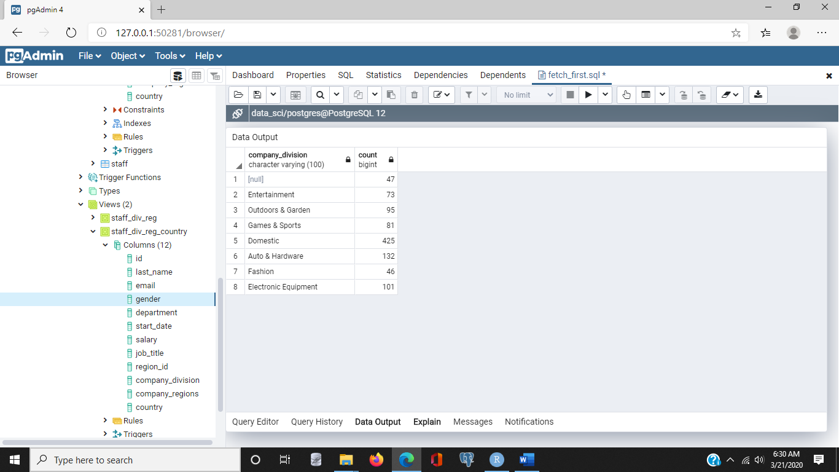So now let's build a simple aggregation query. So I'll remove most of this part of the query, and let's select company division, and count from a staff div reg country view, and let's group by company division, and we'll order by count, and we'll execute.

select

company_division, count(*)

from

staff_div_reg_country

group by

company_division;

And we have a list here, so let's tweak this list a little bit, let's make it in descending order, and I'll do that by adding the descending, or DESC keyword, so now we have it in descending order, so let's finally add a fetch first and limit the results to the top five divisions by staff count, and we'll do that by specifying fetch first five rows only, and when we execute, five rows are returned, and it happens to be the top five.

/* Use fetch first with order by to select top 5 divisions by staff count */

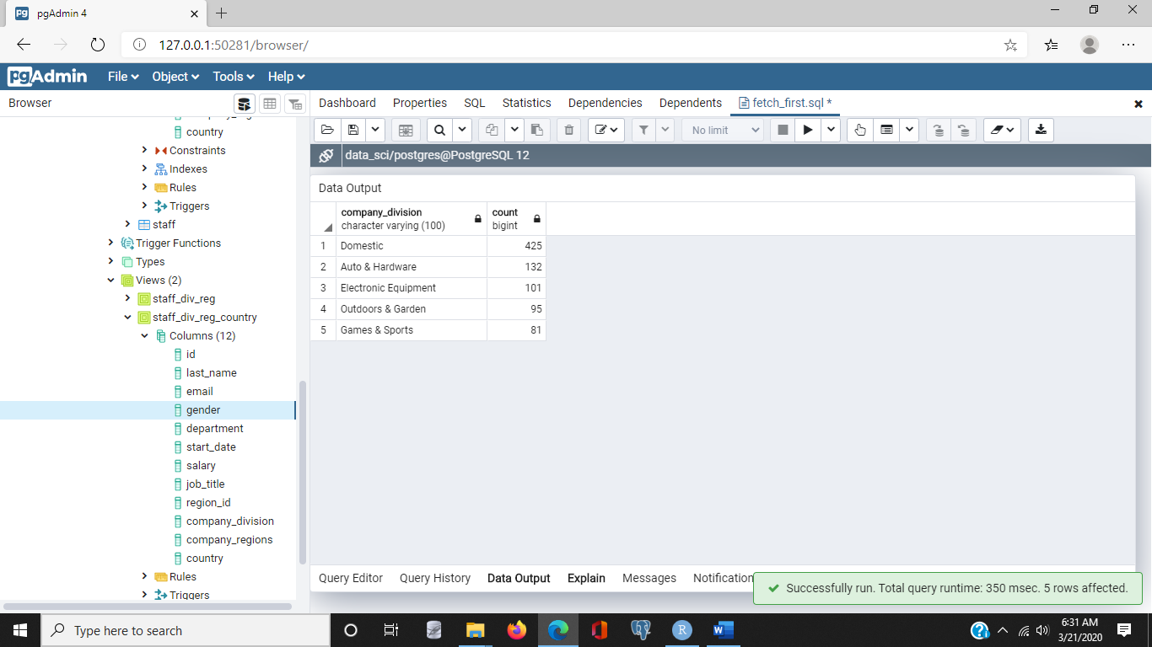select

company_division, count(*)

from

staff_div_reg

group by

company_division

order by

count(*) desc

fetch first

5 rows only;

5. Window Functions and Ordered Data

### Window functions: OVER PARTITION:05_01 file

- [Instructor] **Window functions** allow us to make SQL statements about rows that are related to the current row during processing. This is somewhat like the way subqueries work. They let us do an operation that's related to the current row that SQL is processing. For example, instead of using a subquery to calculate an average salary for an employee's department, we can use a windowing function on rows called **OVER PARTITION**. Let's take a look at an example. Let's select department, last_name, and salary. So that'll list for us the departments, last name, and salaries of each of the employees, but I also want to look at an average salary for each department. I can specify the average salary aggregate and then say I would like to have the average salary over a partition. And I use the phrase **PARTITION BY**, and then specify how I want to do my grouping. In this case, I want to do it by department, and I'll select this from the staff table. So again, what I have is I've selected department, last_name, and salary, and I'm going to also display an average of salary for each department, and that's what the **OVER PARTITION BY** statement does. Let's see what we have here.

/* Select individual salary and average department salary */

select

department,

last_name,

salary,

avg(salary) over (partition by department)

from

staff;

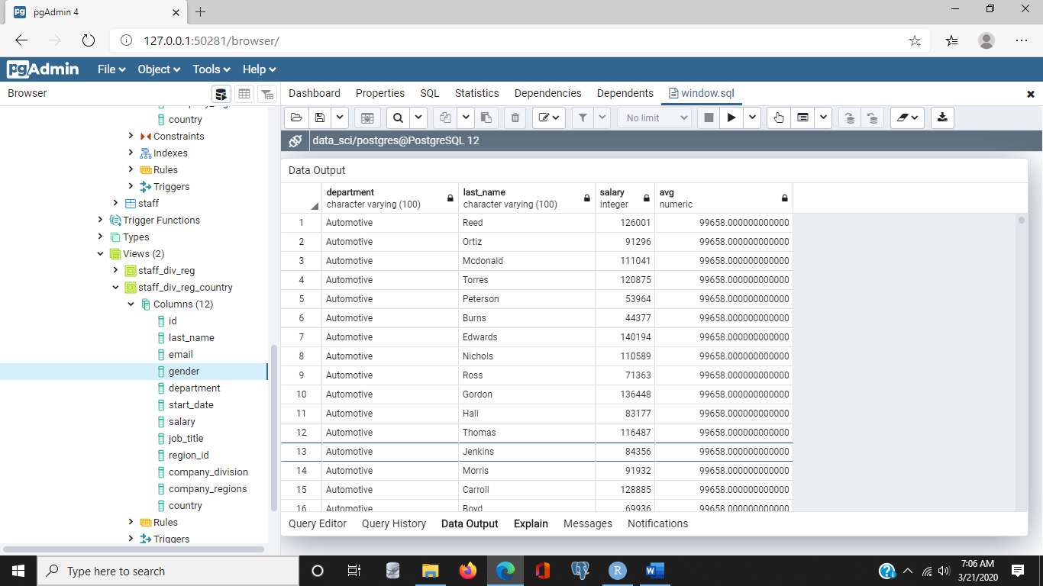

What we'll notice is we have a list ordered by department, and then we have individual's last names, their salary, and then the average salary for each person in that department. So we'll notice for the automotive department, the average salary is 99,658. Now, let's scroll down and see a different department. We'll notice in the baby department the average salary now changes. It's about $93,750.

We can use other aggregate functions too. For example, let's change the average to max, and I'll leave everything else the same. And I'll execute that query. Now what I'm listing includes the department name, the employee's name, the employee's salary, and then the maximum salary in that department. So for example in automotive, the maximum salary is 146,167, and we'll scroll down again to a different department to see that it shifts. In the baby department, the maximum salary is 148,687.

/* Use a windowing operation with a different aggregate function */

select

department,

last_name,

salary,

max(salary) over (partition by department)

from

staff;

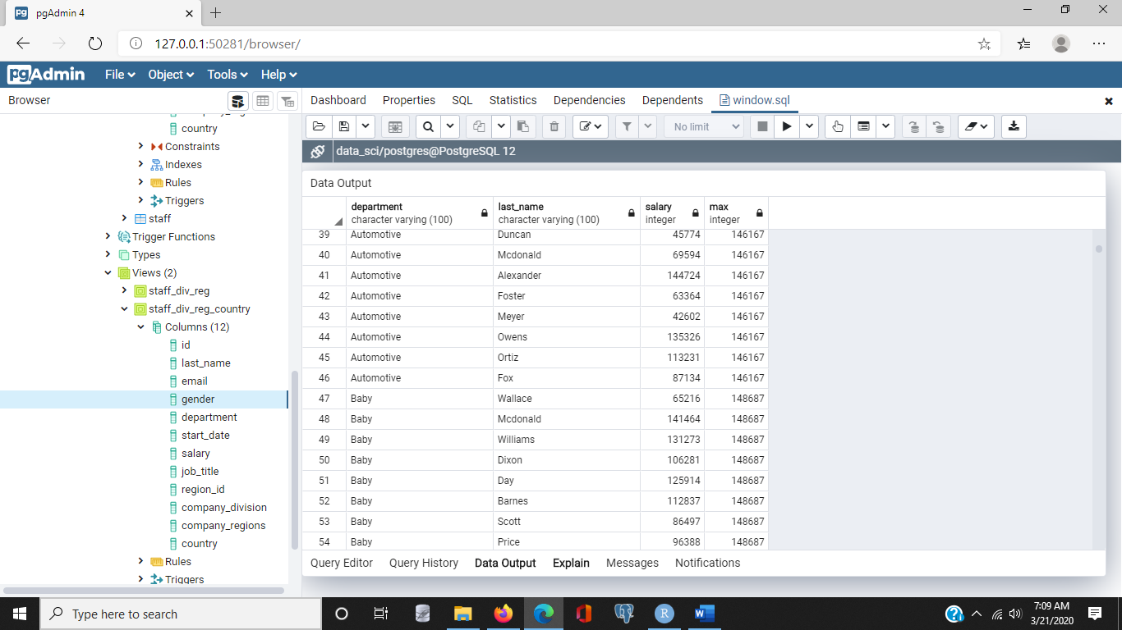

Now, let's change both the aggregate function and the column we partition by. So I'm going to clean up. I'm going to use the view that we had created, and what I'd like to do is SELECT company_regions, last_name, salary, and the minimum salary. And here, I'm going to do it **OVER a PARTITION BY** company_regions. And since I'm referencing company_regions, I'll select from our view which we created earlier called staff_div_reg_country. And I'll execute, and here, what we have is a similar list, but instead of department, we have company_regions, and we have the minimum salary that's earned by anyone in that region. So for example, in British Columbia, the minimum salary is 40,194, but let's scroll down to another region. For example, here in the northeast, the minimum salary is $41,026.

/* Use a windowing operation with a different aggregate function and different grouping */

select

company_regions,

last_name,

salary,

min(salary) over (partition by company_regions)

from

staff_div_reg_country;

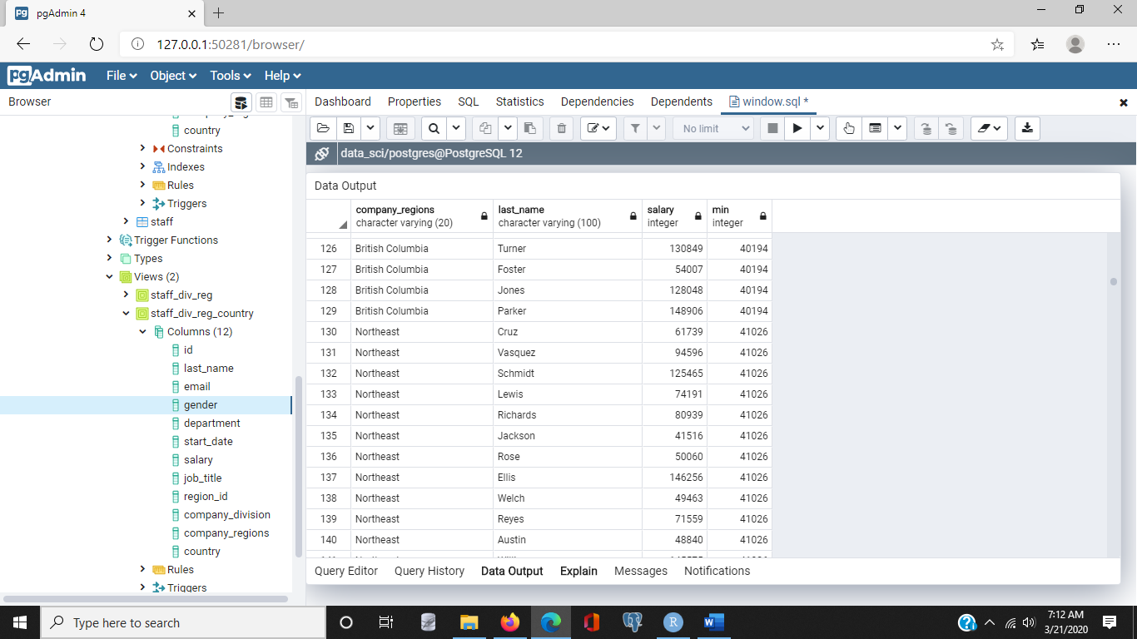

### Window functions: FIRST_VALUE:05_01 file

- [Narrator] We could also select a set of attributes grouped by department and include the first value by department in each row using something called **The First Value Function**. Let's take a look at an example. Let's select department, last name, salary, and now let's put in our function here. I want to select First Value. And I want to select the First Value from the list of salaries and I want that list to be over a **PARTITION** by department. So that's grouping by department. And I want to order it by salary itself and I would like to start at the highest salary and go down to the lowest. So I'm going to use the Descending, or **DESC** keyword here. Now I'm going to select from staff and let's just review this one more time. We have the three columns that we've been using, department, last name and salary. And now I'm saying I want to take the first value in the list of salaries where that list is grouped by or partitioned by department in descending order by salary. So let's execute that and see what happens.

/* Select a set of attributes grouped by department, include the first value by department in each row */

select

department,

last_name,

salary,

first_value(salary) over (partition by department order by salary desc)

from

staff;

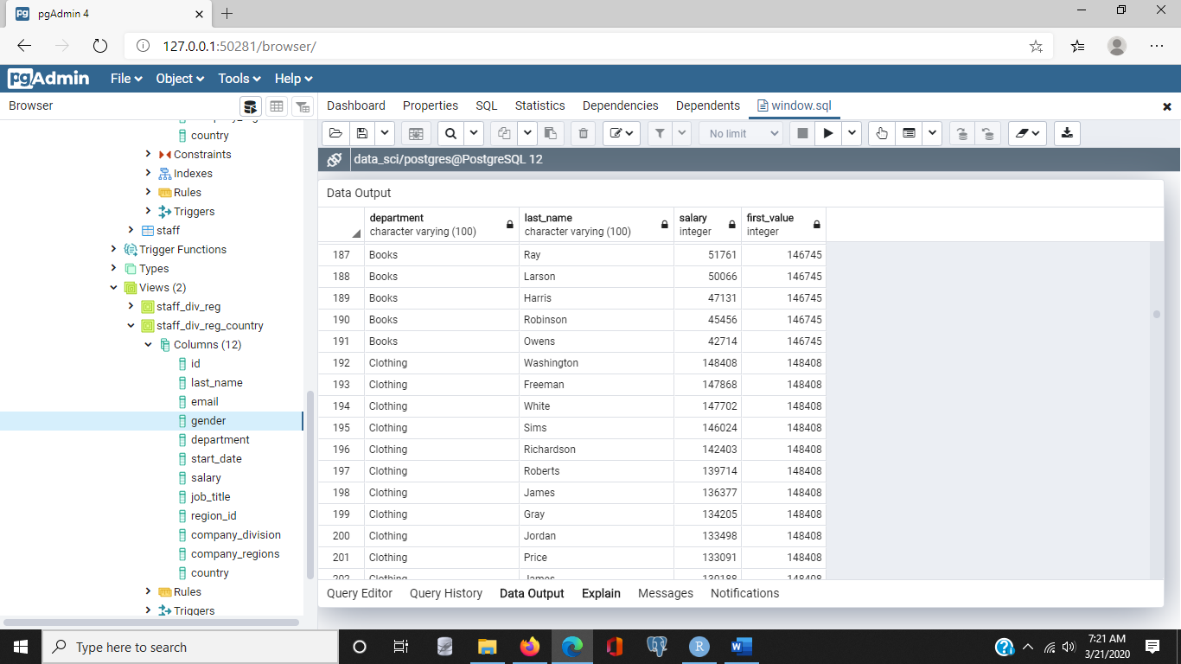

Well, what we have here is a list with departments, employee's last names, and then the salary ordered in descending order. So for example, Sanchez in Automotive earns 146,167 and then each of the employees listed below there is in order of their salary in descending order. But the First Value Function always returns the salary of the first person in the list, grouped by department. So as you'd expect as we scroll down, we'll notice when we shift to the baby department now the top name is Howard, the maximum salary, or in this case the First Value is 148,687 and that's the value that's shown in the First Value Column. Now in this case, First Value returns the same ordering as if we had used the MAX Function. **What's different about First Value** is that we can **change the Order By** Claus. So instead of ordering by salary, let's order by last name and execute. Now what we have is a grouping by departments, so we still have Automotive grouped together. It's ordered by last name, in this case it's in alphabetical order. **The first value is the value of the salary of the person who's name is first in alphabetical order in that department**. So in this case it's someone named Adam who earns 79,045. And what you'll notice is the last names are ordered in alphabetical order, the first value is always the value of Adam's salary. So the first value refers to the first line that appears in the grouping. And as we scroll down into the baby department what we'll notice here is this person earns a salary of 66,847 and that salary continues to show in the First Value Column for everyone in the baby department. So that's the difference between First Value and Max. We can change which value appears as the first value in the list by changing the Order by Claus.

### Window functions: RANK:05_01 file

- Another useful function is the **Rank function**. It works with the **partition** operation to order results and assign a Rank value based on the way the partition data is sorted. Let's look at an example. Let's select department, last name, salary, and now let's introduce the Rank function. And it works with the over partition by operator. And we're going to say we're going to partition by, recruit by department. And we're going to order that by salary. And I'd like to use descending again. So I'll add that. And we'll select this from staff. Now let's execute and see what kind of values we get.

/* Order results and include the relative rank by row */

select

department,

last_name,

salary,

rank() over (partition by department order by salary desc)

from

staff;

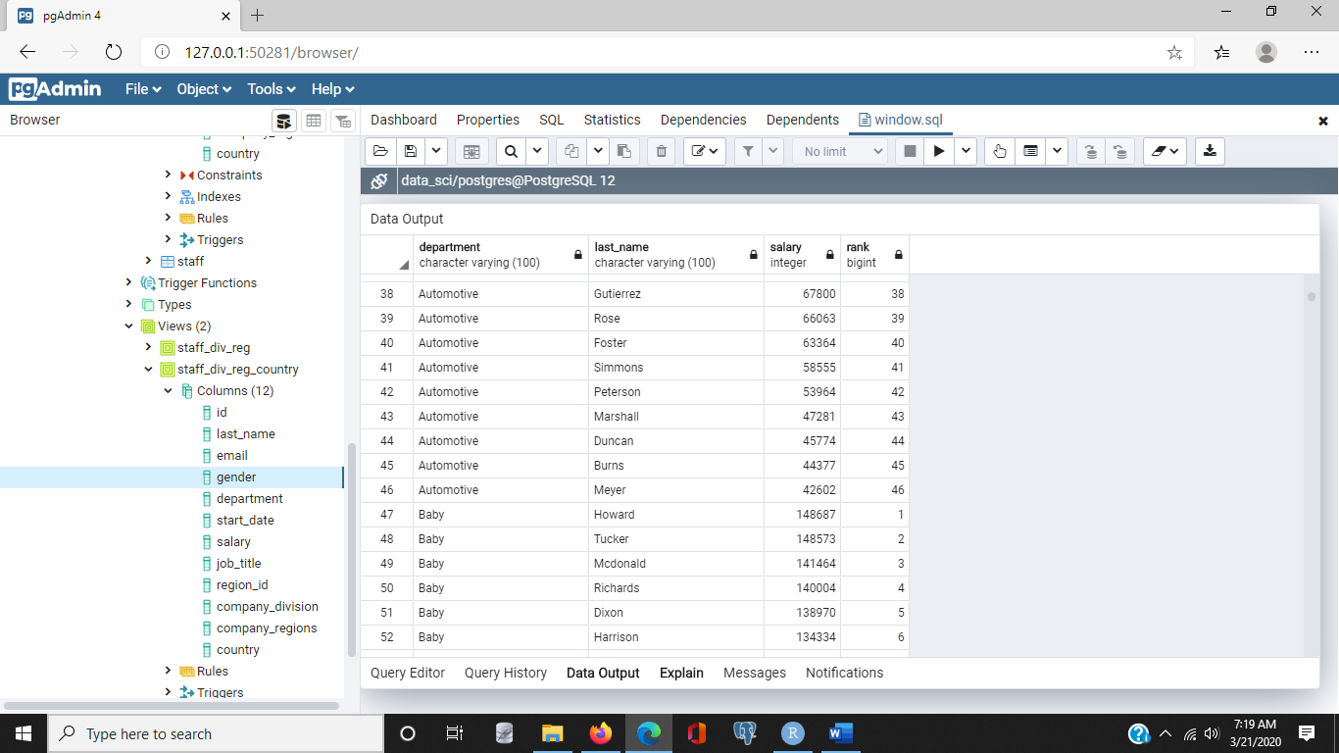

Now what we'll notice here is that we have a familiar set of data. We have a listing by department, with the employees last name and the employees salary. The salaries are sorted in descending order. So the highest is first. And then we also have this column called Rank. And that lists the number one through the number of employees in the department. So Rank tells us where each salary falls in the department. And we'll notice as we move into the next department, in this case, the baby department, the ranking restarts again at number one. And that number one is assigned to the person in the department who has the highest salary. Window functions like Rank can streamline complex queries that would otherwise require sub-queries or multiple queries to process.

/* Window functions can be used to add ranked row numbers */

select

company_division,

last_name,

salary,

row_number() over (partition by company_division order by salary asc)

from

staff_div_reg;

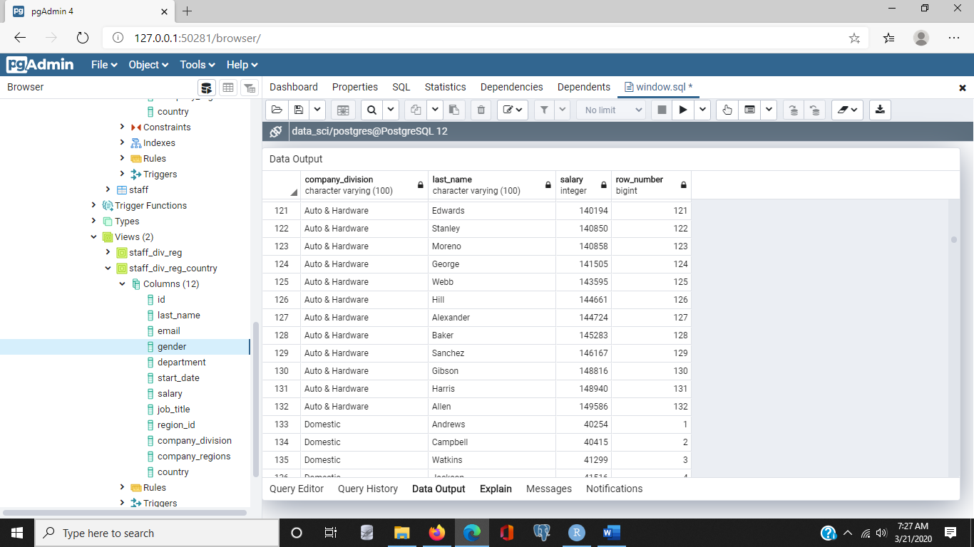

### LAG and LEAD:05_04 file

- [Narrator] Newer versions of SQL provide additional features for operating on rows related to the currently processed row. For example, if you want to know a person's salary and the next lower salary in the department, we could use the **lag function** to reference rows relative to the currently processed rows. So, let's look at an example. We'll select, department, last name, salary. And now we'll introduce the lag function. And I would like to lag on salary over a partition by department and let's order that by salary and we'll use the descending keyword and let's select this from the Staff table.

/* Use lag to reference rows behind */

select

department,

salary,

lag(salary) over (partition by department order by salary desc)

from

staff

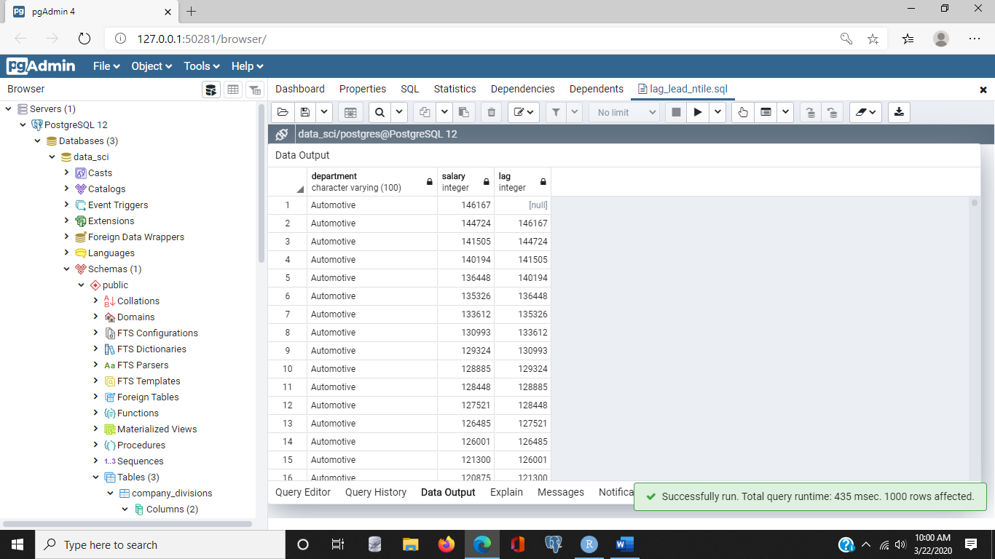

Now, it's best, let's just execute this and look at the results. What we have is a result set that includes the department name, an employee's name, their salary and then a column labeled lag. And what lag is referring to is to the row that came before the currently processed row. So for example, the very first one doesn't have a currently processed row so the lag value is null. But when we move to row two, which is Automotive, the person's name is Alexander. That person's salary is $144,724. The lag or the salary that came before is $146,167. Let's scroll down to the next department and we'll notice the switch again. Here, there's a break when we shift from Automotive to the new department, Baby. Salaries are ordered in a descending order and the first row in this case, Howard, with a salary of $148,687, doesn't have a previous salary. So there's no value there. However, when we move to the second name in the department, Tucker, we'll notice that the lag column has the value of the salary from the previous row. So, lag is one of those operators that works relative to the current row that we're referring to.

Another operator is called **Lead**. Let's take a look at that. Lead is essentially the opposite of lag. Because it refers to the column that comes after the currently processed column.

/* Use lead to reference rows ahead */

select

department,

salary,

lead(salary) over (partition by department order by salary desc)

from

staff

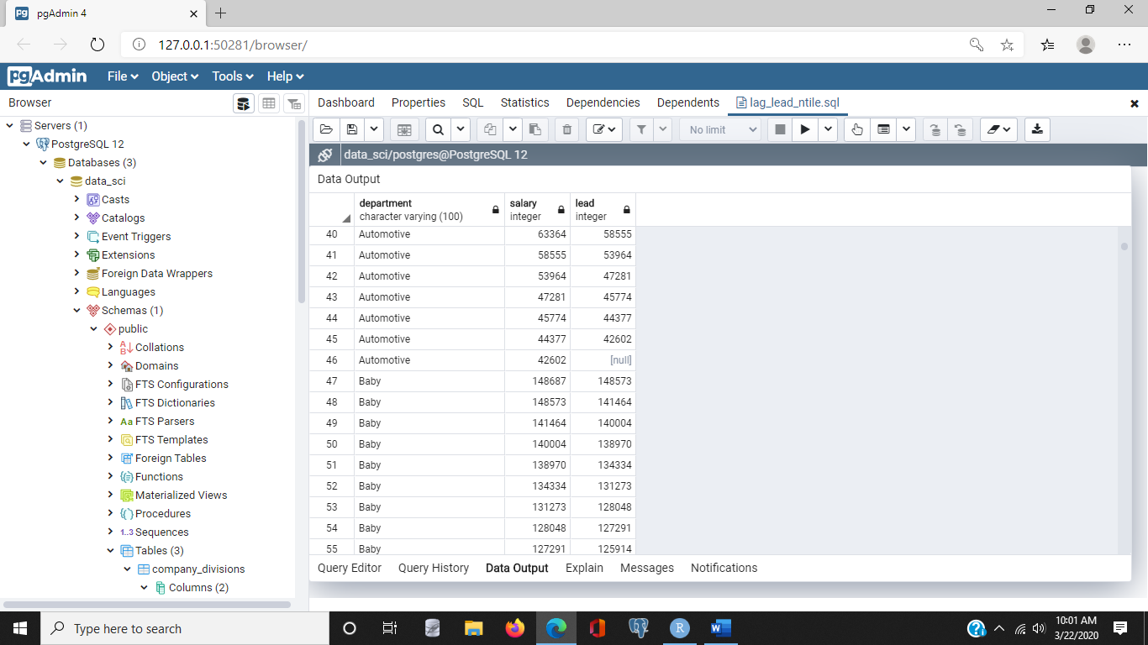

So for example, in row one Sanchez has a salary of $146,167. The lead, the one ahead of it, is $144,724. And again, each row has a department, a last name of an employee, that employee's salary and now it has the leading, or next salary in the list. And we'll see that again, when we switch departments from Automotive to Baby. We'll notice that things are reset. For example, Howard has a salary of $148,687. The next row, or the leading row, has a salary of $148,573 and so on. And we'll notice that the last line of the department, in this case someone named Meyer, with a salary of $42,602, does not have a lead value because there's no other row following it.

### NTILE functions:05_04 file

- [Narrator] Sometimes we want to group rows into some number of buckets or ordered groups. We can use **the ntiles function** to assign buckets to rows. This allows us to easily calculate statistics like core tiles over sets of rows. Here's an example that labels each salary with a core tile of one to four with **one being the group with the largest salaries**, and **four being the smallest set of salaries**. So let's select department, last name, salary. And now let's introduce the ntile function. **Ntile takes a number, and it will be the number of buckets that we want or ordered groups that we want.** So we're going to use core tiles or four groups so I'll specify four and I would like these ntiles over a group that is partitioned by department. And I'd like this ordered by salary, and we'd like that in descending order. Then we'll query this from the staff table.

/* Use ntiles to assign "buckets" to rows */

/* Include quartiles in list of salaries by department */

select

department,

salary,

ntile(4) over (partition by department order by salary desc) as quartile

from

staff;

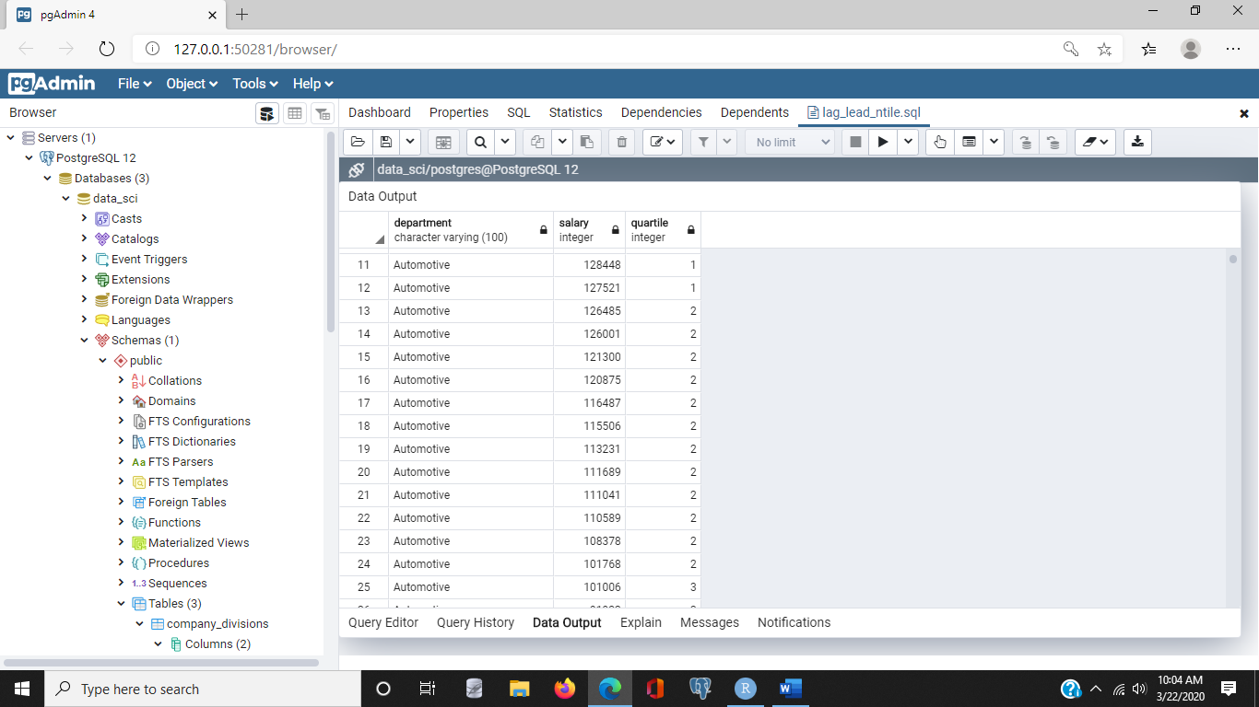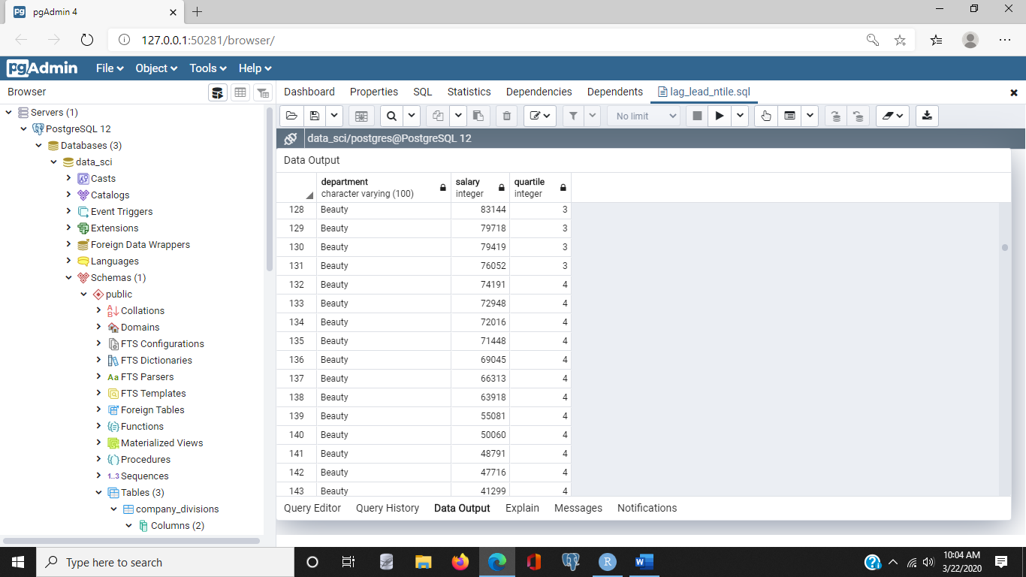

Now when we execute, what we'll notice is, we have a list of departments, each employee in that department and then there's salary and this employees are ordered with the highest salary first and then going down. They also have an integer value assigned to them. In this case, the top earners in the automotive department are assigned number one. Now, the second group is assigned the value of number two. So this is the second group based on the order of salary. And the third group is assigned number three. And then the fourth group has the lowest set of salaries and that's assigned number four. It is important to note, the number of rows in each group is the same, plus or minus one. If the total number of rows is not evenly divisible by the number of buckets, then some of the buckets will have one more row than others. Now also, as you notice, as we shift to a new department, we start the tiling again. In this case, in the baby department, Howard is in the first group as is Tucker and other high earners. And again, if you were to scroll down, you will notice that about a quarter of the way down, we shift to the second tile, or ntile of two. We move another quarter down, and we shift to the ntile of three. And finally, ntile of four. **Ntile is the window function we use when we want to group rows into some number of buckets or ordered groups.**

6. Preparing Data for Analytics Tools

### Tips for using SQL for data science

- [Instructor] The goal of data science is to tell stories using data. The stories we tell start with a business problem, like customers switching to competitors or products not selling as well as they use to. We need data to tell these stories. This data is often stored in multiple databases and file systems so our first task is to pull data from these different data sources and prepare them like a cook preparing ingredients for a dish. As with cooking, if you spend the time getting your data organized and properly prepared, the actual analysis is more enjoyable and goes more smoothly. Here are some tips as you work with SQL for data science. First, data collection and preparation will likely take more time than any other part of the data science project. Be sure to count all data sources when estimating and add extra time if you'll be joining data across different data sources. You may have inconsistent coding schemes or other data quality problems that will require additional time to correct. Aggregate and statistical functions in SQL can help you understand your data. For example, do you have attributes that fall into a bell curve? Or are there many different values and the curve has a long tail? Are there many outliers? Knowing the answers to these questions can help determine the kinds of analyses you try later on. Save yourself some time and do as much formatting and quality checks before attempting to join data from different sources. Use consistent coding schemes for things like states and country names. This helps avoid problems like not including all rows in a group count because some country codes are USA and others are US. Remember that an inner jointed SQL will return rows only when both tables have corresponding rows. If you want all the rows from one table even if there is not a corresponding row in the other table, then use an outer join. SQL statements get complicated especially when using joins, subqueries, and complicated grouping and filtering clauses. Use views to capture this logic so that you can query the view instead of having to repeatedly type in long SQL statements. It's easy to make a mistake when typing in such statements so use views that you can test and verify. And besides, views make it easy to share your SQL logic with others as well. Cubes, rollups, and grouping sets are useful when you need to produce cross-tabulations and subtotals. Now you could use multiple select statements to get the same results, but these operators can be more efficient. And finally, use window functions. They help us focus on sets of related rows such as all rows in a single department or company region. Window functions can help simplify select statements that would otherwise require subqueries.